Port Police Division

Customs and Border Protection
Security Systems Maintenance and Repair

REQUEST FOR PROPOSALS



February 15, 2024
February 15, 2024

Prospective Consultants:

SUBJECT: REQUEST FOR PROPOSALS FOR CUSTOMS AND BORDER PROTECTION SECURITY SYSTEMS MAINTENANCE AND REPAIR

The City of Los Angeles Harbor Department (Harbor Department) invites the submittal of proposals to provide maintenance, repair, installation, and system integration services for the Harbor Department’s security systems located at the World Cruise Center, 100 Swinford Street, San Pedro, CA 90731. These services shall commence after a contract is approved by the Board of Harbor Commissioners.

Instructions and forms to be used in preparing the proposal are found in the information included in the Request for Proposals (RFP).

The schedule for this RFP will be as follows:

Request for Proposals Published | Thursday, February 15, 2024
Questions Due | Thursday, February 22, 2024 by 3pm
Response Posted | Thursday, February 29, 2024
Proposals Due | Thursday, March 14, 2024 by 3pm

If your firm cannot agree to the requirements exactly as set forth in this RFP, please do not submit a proposal.

For questions regarding this RFP, please contact Susana Eldridge by email at Seldridge@portla.org. Questions must be submitted by Thursday, February 22, 2024 by 3pm. Responses will be posted on the Harbor Department’s website and the Regional Alliance Marketplace for Procurement (RAMP), at www.rampla.org, on Thursday, February 29, 2024. It is the responsibility of all proposers to review both websites for any RFP revisions or answers to questions prior to submitting a proposal in order to ensure their proposal is complete and responsive.

In addition to providing information requested in this RFP, it should be noted that there are administrative documents that must be submitted with the proposal. Please refer to the Business Enterprise Programs and Contract Administrative Requirements section of this RFP. In order for your proposal to be deemed responsive, these documents MUST be included with your proposal.

All consultants and subconsultants must be registered on RAMP at the time proposals are due. If selected for award, for-profit companies and corporations must comply with RAMP’s demographic reporting requirements, per the Mayor’s Executive Directive 35.

Sincerely,

TRICIA J. CAREY
Director, Contracts and Purchasing Division

TABLE OF CONTENTS
1. INTRODUCTION 5
1.1 Brief Overview of the Project 5
1.2 The Port of Los Angeles 5
2. PROJECT DESCRIPTION 5
2.1 Project Goals and Objectives 5
2.2 Project Scope of Work 6
3. PROPOSAL REQUIREMENTS 10
3.1 Proposal Questions 10
3.2 Proposal Submission 10
3.3 Evaluation Process and Selection Criteria 11
3.4 Proposal Content 11
3.5 Checklist for RFP Submittal Requirements 15
4. STANDARD CONTRACT PROVISIONS 16
4.1 Affirmative Action 16
4.2 Small/Very Small Business Enterprise Program and Local Business Preference Programs 16
4.3 Business Tax Registration Certificate 16
4.4 Indemnity and Insurance Requirements 17
4.5 Conflict of Interest 21
4.6 Compliance with Applicable Laws 21
4.7 Governing Law / Venue 21
4.8 Termination Provision 21
4.9 Proprietary Information 22
4.10 Trademarks, Copyrights, and Patents 22
4.11 Confidentiality 23
4.12 Notices 23
4.13 Termination Due to Non-Appropriation of Funds 23
4.14 Taxpayer Identification Number 24
4.15 Service Contractor Worker Retention Policy and Living Wage Policy Requirements 24
4.16 Wage and Earnings Assignment Orders/Notices of Assignments 24
4.17 Equal Benefits Policy 24
4.18 State Tidelands Grants 24
4.19 Contract Solicitations Charter Section 470 (c) (12) 25
4.20 Recordkeeping And Audit Rights 25

ATTACHMENTS / EXHIBITS
Exhibit A - Affirmative Action Program Provisions
Exhibit B – Small/Very Small Business Enterprise Program
Exhibit C – Proprietary Small Business Enterprise Application
Exhibit D - Business Tax Registration Certificate (BTRC) Number
Exhibit E - Equal Benefits Ordinance
Exhibit F - RFP Selection Evaluation Form
Exhibit G – City Ethics Commission (CEC) Forms 50 and 55

INTRODUCTION

Brief Overview of the Project

The Los Angeles Port Police is soliciting proposals from qualified firms to provide software and hardware maintenance, repair, installation, and system integration services at the World Cruise Center, located at 100 Swinford Street, San Pedro, CA 90731. There are approximately 150 cameras associated with the Closed Circuit Television (CCTV) system and approximately 64 access control points as well as any new associated systems coming on line during the life of this contract. The World Cruise Center operates on 18 acres and three berths and serves multiple cruise lines. In 2022, approximately one million passengers traveled to and from the Port of Los Angeles via 229 ship calls.

The duration of the contract awarded as a result of this RFP is expected to be one year from the date of execution of the agreement with two, one-year renewal options thereafter.

The Port of Los Angeles
The Port of Los Angeles is America’s Port®, the nation’s premier gateway for international commerce and the busiest seaport in the Western Hemisphere. Located in San Pedro Bay, 25 miles south of downtown Los Angeles, the Port encompasses 7,500 acres of land and water along 43 miles of waterfront.
The Port features both passenger and cargo terminals, including cruise, container, automobile, breakbulk, dry and liquid bulk, and warehouse facilities that manage billions of dollars’ worth of cargo each year. One of the world’s busiest seaports and leading gateway for international trade in North America, the Port of Los Angeles has ranked as the number one container port in the United States each year since 2000. In 2023, the Port handled a total of 8.6 million container units.
The Port of Los Angeles is a department of the City of Los Angeles (also known as the Los Angeles Harbor Department) and is governed by the Los Angeles Board of Harbor Commissioners, a panel appointed by the Mayor of Los Angeles. Although the Port is a City department, it is not supported by City taxes. Operating as a landlord port with more than 200 leaseholders, the Port instead generates its revenues from leasing and shipping service fees. The Port’s jurisdiction is limited to the Harbor District, which includes property in San Pedro, Wilmington, and Terminal Island.

PROJECT DESCRIPTION

Project Goals and Objectives

The selected Consultant shall perform maintenance services on a time-and-material basis, under the direction of the Homeland Security Manager (HLS Manager), or their designee (collectively referred to as “HLS Manager”). With the exception of emergency repairs, all tasks will be directed in writing, by Projective Directive, from the HLS Manager.

When and where applicable, all work shall abide by the following codes, specifications, regulations and standards:

- American National Standards Institute (ANSI)
- Building Industry Consulting Service International (BICSI)
- California State Administrative Code, Title 24, State Building Standard
- California State Occupational Safety and Health Act (Cal/OSHA)
- City of Los Angeles Electrical, Fire, and Building Codes
- City of Los Angeles Department of Water and Power (LADWP)
- Electronic Industries Alliance (EIA)
- Institute of Electrical and Electronics Engineers (IEEE)
- National Electrical Code (NEC)
- National Electrical Manufacturers Association (NEMA)
- National Fire Protection Association (NFPA)
- Telecommunications Industry Association (TIA)
- Underwriters Laboratories, Inc. (UL)

Project Scope of Work

The Harbor Department intends to select a firm to provide services on an on-call basis. Under direction of the HLS Manager, the selected Consultant will provide maintenance and repair services for the CCTV, access control, and intrusion detection systems. The current system consists of approximately 150 cameras and over 64 access control readers, some with keypads. The network that links these sub-systems is comprised of hard-wired and wireless communications infrastructure.

The system includes, but is not limited, to the following:

Hardware:

Networking System: Cisco Catalyst
Workstations/Servers: Dell Precision/Dell PowerEdge
Storage Network (SAN): Dell SCV
Access Control: AMAG Symmetry HSE
Access Readers: HID pivCLASS
Cameras: Pelco, FLIR, Axis
UPS: Eaton

Software:

VM Ware: vSphere and vCenter Server 7
Operating System: Windows Server 2016
Video Management System: Milestone XProtect Corporate
IOT Security Platform: Securithings Horizon
Server Management: Dell OpenManageEnterprise
SAN Management: Dell Unisphere Central

The following items shall be part of the scope of work for this project:

Service Calls
All service calls must be logged and tracked. Proposals shall describe, in detail, how this task will be accomplished. The following types of service calls occur:

Emergency Calls – Calls that warrant immediate repair, as determined by the HLS Manager will require that a qualified service representative arrive on site within two hours of the time the call is acknowledged by the service representative.

Routine Calls – Routine calls, as determined by the HLS Manager, shall be acknowledged by phone or email within one hour and, at the discretion of the HLS Manager, response may be deferred to the start of the following business day.

Facilities and Equipment

Selected Consultant shall, at their own expense, provide any vehicles, tools, or test equipment necessary for on-site technicians to provide 24-hour maintenance coverage.

Corrective Maintenance

Selected Consultant shall be responsible for conducting proactive and preventive system inspections and shall be required to follow up immediately with an investigation of any reported or observed equipment malfunction. Equipment malfunction is defined as the inability of the individual components, subassemblies, or major items of the system to perform their specific functions including equipment failure caused by actions of operational personnel, the public or environmental conditions. If the problem is determined to be due to neither equipment nor system issues, selected Consultant will notify the HLS Manager.

Unscheduled maintenance shall include inspections and tests required to determine the extent of any equipment malfunction, as well as the repair required to correct the problem.

Preventive Maintenance

Scheduled preventive maintenance and service includes, but is not limited to, inspecting, testing, cleaning, adjusting, repairing, acquiring replacement parts and scheduled overhauls as required during the length of the maintenance service contract. This includes routine cleaning of the server, PC workstations, sensors, cameras, card readers, and other components associated with the system. The selected Consultant shall not schedule disruptive preventive maintenance during peak periods of operation. It is necessary to perform such maintenance during off-peak periods, and in coordination with the Harbor Department. These time periods will be established in the Project Directives,

The selected Consultant shall maintain all records of maintenance activities performed. Proposals should include, in detail, how these activities will be tracked ensuring the information gathered includes the history of maintenance and repair activities, the duration, cause, and corrective action taken due to failure of any item. The information tracked must also contain all preventive and routine service work, rotation of equipment, and software updates. These records must be accessible to the HLS Manager. Additional reports/information shall be provided to the HLS Manager, upon request. All documentation must be submitted in electronic form.

To ensure participation by AMAG/Milestone in all aspects of system and hardware support, selected Consultant shall secure service agreements with AMAG and Milestone and any other authorized service centers deemed necessary to ensure that all AMAG/Milestone equipment is serviced appropriately. This shall be included in the maintenance service agreement.

Spare Parts

The selected Consultant must maintain a spare parts inventory service for all aspects of the CCTV and intrusion detection/access control system. The spare parts inventory must contain those items necessary for the normal course of operations, including restoration of all parts of the system. All replacement parts shall be new. No substitutions will be accepted on any equipment. The spare parts shall be stored on-site as designated by the Harbor Department. The selected Consultant shall maintain a record of the status of all spare parts. Please describe what tool(s) will be used to manage assets. The spare parts inventory will become the property of the Harbor Department at the conclusion of the contract term, without further cost to the Harbor Department.

Documentation

In the event the Harbor Department requests the selected Consultant make any additions or changes to the system during the term of the contract, complete as-built drawings, including manufacturer’s literature, training manuals, maintenance manuals, wiring and cabling diagrams, network and system diagrams, and an inventory list of all equipment provided, will be required. These diagrams shall detail point-to-point connectivity for each device. The selected Consultant shall identify the manufacturer, model, serial number, software version, and functions of the components for each system and subsystem included in the list.

The selected Consultant shall be responsible for updating the existing documentation with any necessary technician notes, including unique or non-standard equipment installations. The existing documentation shall be updated with all changes to equipment, including additions, deletions, and moves by means deemed appropriate by the HLS Manager.

Equipment Replacement, Upgrades and Enhancements

Various components and equipment may require replacement during the term of the contract. All labor associated with the replacement, upgrade or enhancement of the equipment shall be billed at the labor rates outlined in selected Consultant’s fee schedule.

All new installations will be inspected by the HLS Manager for quality of workmanship and component and system functionality. The selected Consultant shall be responsible for any corrections to the installations that result from poor workmanship or non-adherence to City, State, and/or Federal standards.
The selected Consultant shall provide pricing estimates for future replacements, updates, and moves, in line item or unit pricing format, prior to any work performed. The pricing estimate, at a minimum, must include: a description of the work to be performed, a complete equipment list with related prices for each item, estimated labor hours, and any equipment required to complete the tasks. Any work performed by a subconsultant must also use the same format. Lump sum price quotations will not be accepted.

Warranty

The selected Consultant shall guarantee any additional work, including system enhancements, from inferior or faulty material or workmanship, and from work not in accordance with the manufacturer’s specifications, for a minimum of one year from the date of project acceptance. Additional work shall be construed as anything added to the current system. The selected Consultant shall warrant all workmanship and materials for additional work for one year.

Security Areas/Security Identification

All personnel with access to security sensitive information are required to pass a background check performed by an entity deemed suitable by the Harbor Department. The selected Consultant may be required to perform work in areas that are “secure” from access to the general public. In such cases, it will be the responsibility of the selected Consultant to complete a detailed background investigation, as required, and submit the results to the HLS Manager prior to commencing work. In addition, it will be the responsibility of the selected Consultant to obtain all necessary identification for each employee who will work at a secure location; this may include the Transportation Worker Identification Credential (TWIC), obtained at the selected Consultant’s expense.

Safety Clearance
The selected Consultant may be required to perform work in areas that have safety course requirements. These requirements may vary by site and shall be completed at the selected Consultant’s expense. In such cases where the selected Consultant is required to work in a “hazardous location,” it will be the responsibility of the selected Consultant to successfully complete the courses necessary to obtain appropriate documentation, identification, and/or clearance for all employees who work at that location. The Harbor Department will provide a list of the required courses as well as locations and times that the courses will be offered.
In addition to the above, the selected Consultant must have a thorough knowledge of, and where, indicated, certification for:

1. Infrastructure
- VMware v7
- FireEye DTI Endpoint Security Essentials
- Cisco CCNA

2. Service Delivery
- IT Asset Management

3. Access Control (certified resource)
- AMAG Symmetry HSE

4. Video Management System (certified resource)
- Milestone XProtect Corporate

PROPOSAL REQUIREMENTS

Proposal Questions

All questions regarding this RFP must be submitted, in writing, exclusively to Susana Eldridge the Contract Administrator, at Seldridge@portla.org by no later than 3 p.m. on Thursday, February 22, 2024.

Attempts to contact any other Harbor Department employee or members of the Board of Harbor Commissioners, either directly or through third-parties acting for or on the proposer's behalf, may be presumed to constitute efforts to bias or influence the competitive process with information not detailed in the RFP and not available on an equal basis to all proposers. Accordingly, such attempts shall constitute grounds to disqualify the proposer undertaking them. Any information provided by the Contract Administrator to one proposer in response to questions shall be provided to all proposers.

Proposal Submission

One (1) digital copy of your proposal, as one complete file in .pdf format, must be submitted on or before 3:00 p.m. PST on Thursday, March 14, 2024 to:

ATTN: Susana Eldridge at Seldridge@portla.org
REF: Customs and Border Protection Security Systems Maintenance and Repair

The proposal shall be in searchable PDF (Portable Document Format). Files shall not be password protected or saved with restrictions that prevent copying, saving, highlighting, or reprinting of the contents. The electronic copy will not be returned.

Proposers solely are responsible for the timeliness of their submittals. As such, proposers are cautioned to budget adequate time to ensure that their proposals are delivered before the deadline set forth above.

By submitting a proposal, proposers certify that such proposal constitutes their full and complete written response to the RFP and evidences their acknowledgement that additional written material outside of such proposal shall not be considered by the City in connection with this RFP, unless the City provides a written request that they submit additional written materials. Absent such written request, proposers are instructed to not submit to the City written or other materials outside of the proposal, either in a subsequent interview or otherwise.

Evaluation Process and Selection Criteria

All proposals meeting the requirements of this RFP shall be reviewed and rated by an evaluation committee according to the following criteria: 1) firm qualifications, experience, and references; 2) project organization, personnel, and staffing; 3) project approach, work plan, and management; 4) rates, fees, and budget control, and 5) clarity and comprehensiveness of the proposal. See Exhibit F.

Selected proposers may be contacted to arrange in-person interviews with the evaluation committee. The evaluation committee will make the final recommendation for selecting the consultant. All recommendations are subject to the approval of the Chief of Port Police, the Executive Director of the Harbor Department, and the Board of Harbor Commissioners.

Proposers are advised that all documentation submitted in response to this RFP will be considered property of the Harbor Department and may become available to the public as a public record and be released without further notification. Any information that the proposer considers confidential should not be submitted with the proposal.

The right to reject any and all proposals shall, in every case, be reserved, as shall the right to waive any informality in the proposal when to do so would be to the advantage of the City.

Proposal Content

The following items shall be included in your proposal:

1. Cover Transmittal Letter

Provide a narrative which introduces the firm and team highlighting the special strengths of the firm to perform the work requested in this RFP. The letter should be signed by an authorized principal of the proposing consulting firm.

2. Firm Qualifications, Experience and References

Provide a narrative describing the firm’s qualifications to perform the project work, including past (relevant) experience and at least three client references, with contact names and information. Include information regarding your firm’s experience involving the size and level of complexity of the proposed project. Qualifications and experience for proposed subconsultants should also be included.

Identify any members of your proposed team, including proposer’s firm and any subconsultant firms, who are former Commissioners, officers or employees of the Harbor Department. Provide their name, proposed team position, and their past position and years of employment/appointment with the Department. If your proposed team does not have any such members, please include a statement in your proposal so stating.

Proposers are advised that it is a proposer’s obligation to determine whether any conflicts of interest exist for their team members and the extent to which those conflicts need to be resolved or disclosed prior to engaging in business with the Department.

3. Project Organization, Personnel and Staffing

Provide a brief description of all key personnel and technical staff (including vendors, partners or subconsultants) to be involved and their relationship to the services to be provided.

- Include names, titles, licenses, certificates, fields of expertise, and relevant experience for all proposed personnel and staff.
- Identify the Project Manager for the proposed services. It is highly desirable that this individual be certified on Milestone 2019 and AMAG 8.1.
- Identify the Onsite Support Manager for the proposed services. This individual must be certified on Milestone 2019 and AMAG 8.1.
- Include documentation demonstrating that the firm has qualified personnel, resources, technical experience and expert credentials, such as Transportation Worker Identification Credential (TWIC), or technician/administrator certifications from AMAG, Milestone, Cisco, etc., to service and maintain the system.
- Include documentation that key personnel, particularly those who will be working on the network, have, at minimum, a Cisco Certified Network Associate certificate (CCNA).

4. Project Approach and Work Plan

Provide a narrative which shows your firm’s understanding of the project’s requirements and documents a logical technical approach to the project scope of work. Include a general work plan as well as the proposed approach to undertaking the scope of work described earlier in this RFP.

5. Project Management

Describe how your firm intends to manage all aspects of the work to be performed, including schedules for completion of tasks/subtasks, procedures for scheduling and cost control. Please describe what tool(s) will be used to manage assets and inventory.

6. Cost

Provide pricing and cost information for the project. Include hourly rates for all proposed team members. Also provide pricing for any proposed equipment, software, or hardware costs and any other related expenses for the project. Discuss any budget control measures of your firm and proposed subconsultants.

7. Business Enterprise Programs and Contract Administrative Requirements

In order for your proposal to be deemed responsive, the following documents MUST be included with your proposal:

- SMALL/VERY SMALL BUSINESS ENTERPRISE AND LOCAL BUSINESS PREFERENCE PROGRAMS (EXHIBIT B)

Provide with your proposal the Small/Very Small Business Enterprise and Local Business Preference Programs Affidavit and Consultant Description forms (Exhibit B), fully filled out for your firm and any proposed subconsultants. Please refer to Exhibit B for detailed information relative to these programs and instructions on completing the forms.

Although there is not a mandatory Small Business Enterprise (SBE) or Very Small Business Enterprise (VSBE) participation requirement for this contract opportunity, both forms in Exhibit B must be submitted with your proposal.

Firms must be certified as SBEs or Very Small Business Enterprises (VSBE) through RAMP at the time proposals are due. Firms will only receive credit for SBE/VSBE certifications reflected on their RAMP profile. Firms may certify as SBE (Proprietary) and VSBE (Harbor) by completing the SBE (Proprietary) application (Exhibit C). Please refer to the Road Map in Exhibit C for a listing of agency certifications that may be accepted in lieu of completing the application. For VSBE certification, you must complete the application or be certified as a Micro-business through the State of California Department of General Services (DGS). If your firm is certified by one of the listed agencies, you must complete the instructions in the application in regards to obtaining certification on RAMP. Applications should be mailed to the following address referencing the RFP:

CITY OF LOS ANGELES
DEPARTMENT OF PUBLIC WORKS
Bureau of Contract Administration
Office of Contract Compliance – Centralized Certification Administration
1149 S. Broadway, Ste. 300
Los Angeles, CA 90015

Proposers who qualify as a Local Business Enterprise (LBE) will receive an 8% preference on any services valued in excess of $150,000.

- INSURANCE VERIFICATION LETTER

Provide a letter from your insurance carrier or broker indicating that the insurance requirements for this project as described in this RFP are presently part of the proposer’s coverage, or that the insurance company is able to provide such coverage should the proposer be selected. The insurance carrier/broker must be aware of the indemnification requirements also set forth in this RFP. Proposers are not required to purchase the required insurance in order to respond; however, all required insurance will need to be submitted at the time of contract award. ACORD® Certificate of Liability Insurance sheets will not be accepted in lieu of an insurance verification letter. Proposals submitted without an insurance verification letter, as described above, will be deemed non-responsive.

- CITY ETHICS COMMISSION (CEC) FORMS 50 and 55

Proposers who submit a response to this solicitation (proposers) are subject to Charter section 470 (c) (12) and related ordinances. As a result, proposers may not make campaign contributions to and or engage in fundraising for certain elected City officials or candidates for elected City office from the time they submit the response until either the contract is approved or, for successful proposers, 12 months after the contract is signed. The proposer’s principals and subcontractors performing $100,000 or more in work on the contract, as well as the principals of those subcontractors, are also subject to the same limitations on campaign contributions and fundraising.

Proposers must submit CEC forms 50 and 55 to the awarding authority at the same time the response is submitted (See Exhibit G). The forms require proposers to identify their principals, their subcontractors performing $100,000 or more in work on the contract, and the principals of those subcontractors. Proposers must also notify their principals and subcontractors in writing of the restrictions and include the notice in contracts with subcontractors. Responses submitted without completed CEC Forms 50 and 55 may be deemed non-responsive. Proposers who fail to comply with City law may be subject to penalties, termination of contract, and debarment. Additional information regarding these restrictions and requirements may be obtained from the City Ethics Commission at (213) 978-1960 or ethics.lacity.org.

- ACCEPTANCE OF STANDARD CONTRACT PROVISIONS AND EXECUTIVE DIRECTIVE 35

Proposers are advised that pursuant to Executive Directive (ED) 35, if your firm is a for-profit company or corporation and is selected for award, you shall, within 30 days of the effective date of the contract and on an annual basis thereafter (i.e., within 30 days of the anniversary of the effective date of the contract), report the following information to the City via the Regional Alliance Marketplace for Procurement (RAMP) or via another method specified by the City:

- Annual revenue
- Number of employees
- Location
- Industry
- Race/ethnicity and gender of majority owner

On an annual basis, the consultant shall further request that any subconsultant input or update its business profile, with the above information, on RAMP or via another method prescribed by City.

Proposers must submit a signed letter confirming their intention to comply with the RAMP demographic reporting requirements of ED 35, and their firm's acceptance of all of the Standard Contract Provisions exactly as set forth in Section 4. Do not submit your demographic information in the letter; only the selected consultant needs to enter that information into RAMP, after contract award.

Checklist for RFP Submittal Requirements

A checklist is provided to assist in verification that all elements of the RFP have been addressed. However, firms are encouraged to review the entirety of the RFP, including the Standard Contract Provisions section, to ensure full compliance and not rely solely on this checklist.

- Cover transmittal letter, signed by an authorized principal of the proposing consulting firm
- Table of Contents, if included (not required)
- Proposal with the following sections, in order:
- Firm Qualifications, Experience and References
- Project Organization, Personnel and Staffing
- Project Approach and Work Plan
- Project Management
- Cost
- Resumes for all proposed staff personnel provided in an appendix
- Small/Very Small Business Enterprise and Local Business Preference Program forms:
    - Affidavit of Company Status (Prime)
    - Consultant Description Form (Prime and any subconsultants)
- Letter from insurance carrier or broker indicating ability to meet insurance requirements for this project, including general liability, auto liability, professional liability, and workers’ compensation. Do not submit an ACORD® Certificate of Liability Insurance sheet. It will not be accepted in lieu of an insurance verification letter.
- CEC Form 50 (Bidder Certification)
- CEC Form 55 (Prohibited Contributors (Bidders))
- Letter of acceptance of Standard Contract Provisions and Executive Directive 35

STANDARD CONTRACT PROVISIONS

The following sections are standard contract provisions for the Harbor Department. In submitting a proposal, proposer agrees to accept these terms without change. If your firm cannot agree to the following requirements, exactly as set forth below, please do not submit a proposal.

Affirmative Action

Consultant, during the performance of the Agreement, shall not discriminate in its employment practices against any employee or applicant for employment because of the employee’s or applicant’s race, religion, national origin, ancestry, sex, age, sexual orientation, disability, marital status, domestic partner status, or medical condition. The provisions of Section 10.8.4 of the Los Angeles Administrative Code shall be incorporated and made a part of the agreement. All subcontracts awarded shall contain a like nondiscrimination provision. See Exhibit A.

Small/Very Small Business Enterprise Program and Local Business Preference Programs

It is the policy of the Department to provide Small Business Enterprises (SBE), Very Small Business Enterprises (VSBE), Minority-Owned, Women-Owned, Disabled Veteran-Owned and all Other Business Enterprises (MBE/WBE/DVBE/OBE) an equal opportunity to participate in the performance of all City contracts in all areas where such contracts afford such participation opportunities. Consultant shall assist the City in implementing this policy and shall use its best efforts to afford the opportunity for SBEs, VSBEs, MBEs, WBEs, DVBEs, and OBEs to achieve participation in subcontracts where such participation opportunities present themselves and attempt to ensure that all available business enterprises, including SBEs, VSBEs, MBEs, WBEs, DVBEs, and OBEs, have equal participation opportunity which might be presented under this Agreement. See Exhibit B.

It is also the policy of the Department to support an increase in local and regional jobs. The Department’s Local Business Preference Program aims to benefit the Southern California region by increasing jobs and expenditures within the local and regional private sector. Consultant shall assist the City in implementing this policy and shall use its best efforts to afford the opportunity for Local Business Enterprises to achieve participation in subcontracts where such participation opportunities present themselves. See Exhibit B.

NOTE: Prior to being awarded a contract with the Harbor Department, all consultants and subconsultants must be registered on the City’s Contracts Management and Opportunities Database, Regional Alliance Marketplace for Procurement (RAMP), at http://www.RAMPLA.org.

Business Tax Registration Certificate

The City of Los Angeles, Office of Finance requires the implementation and enforcement of Los Angeles Municipal Code Section 21.09 et seq. This section provides that every person, other than a municipal employee, who engages in any business within the City of Los Angeles, is required to obtain the necessary Business Tax Registration Certificate and pay business taxes. The City Controller has determined that this Code Section applies to consulting firms that are doing work for the Los Angeles Harbor Department. See Exhibit D.

Indemnity and Insurance Requirements

REQUIRED AT PROPOSAL STAGE: A letter from each proposer’s carrier or broker must be provided with their proposal. The letter should indicate that the requirements below are presently part of the proposer’s coverage, or that the carrier/broker is able to provide such coverage should the proposer be selected. The carrier/broker must be aware of the indemnification requirements below. Proposers are not required to purchase the required insurance in order to respond, however all required insurance will need to be submitted at the time of contract award. ACORD® certificates will not be accepted.

- Indemnification

Except for the sole negligence or willful misconduct of the City, or any of its Boards, Officers, Agents, Employees, Assigns and Successors in Interest, Contractor undertakes and agrees to defend, indemnify and hold harmless the City and any of its Boards, Officers, Agents, Employees, Assigns, and Successors in Interest from and against all suits and causes of action, claims, losses, demands and expenses, including, but not limited to, attorney's fees (both in house and outside counsel) and cost of litigation (including all actual litigation costs incurred by the City, including but not limited to, costs of experts and consultants), damages or liability of any nature whatsoever, for death or injury to any person, including Contractor’s employees and agents, or damage or destruction of any property of either party hereto or of third parties, arising in any manner by reason of the negligent acts, errors, omissions or willful misconduct incident to the performance of this Contract by Contractor or its subcontractors of any tier. Rights and remedies available to the City under this provision are cumulative of those provided for elsewhere in this Contract and those allowed under the laws of the United States, the State of California, and the City.

2. Acceptable Evidence and Approval of Insurance

Electronic submission is the required method of submitting Consultant’s insurance documents. Consultant’s insurance broker or agent shall register with the City’s online insurance compliance system KwikComply at https://kwikcomply.org/ and submit the appropriate proof of insurance on Consultant’s behalf.

Carrier Requirements

All insurance which Consultant is required to provide pursuant to this Agreement shall be placed with insurance carriers authorized to do business in the State of California and which are rated A-, VII or better in Best’s Insurance Guide. Carriers without a Best’s rating shall meet comparable standards in another rating service acceptable to City.

Primary Coverage

The coverages submitted must be primary with respect to any insurance or self insurance of the City of Los Angeles Harbor Department. The City of Los Angeles Harbor Department’s program shall be excess of this insurance and non-contributing.

Notice Of Cancellation

For each insurance policy described below, the Consultant shall give the Board of Harbor Commissioners a 10-days prior notice of cancellation or reduction in coverage for nonpayment of premium, and a 30-days prior notice of cancellation or reduction in coverage for any other reason, by written notice via registered mail and addressed to the City of Los Angeles Harbor Department, Attention Risk Manager and the City Attorney’s Office, 425 S. Palos Verdes Street, San Pedro, California 90731.
Modification of Coverage
Executive Director, at his or her discretion, based upon recommendation of independent insurance consultants to City, may increase or decrease amounts an types of insurance coverage required hereunder at any time during the term hereof by giving ninety (90) days’ written notice to Consultant.
Renewal of Policies
At least thirty (30) days prior to the expiration of any policy, Consultant shall direct their insurance broker or agent to submit to the City’s online insurance compliance system KwikComply at http://kwikcomply.org a renewal certificate showing that the policy has been renewed or extended or, if new insurance has been obtained, evidence of insurance as specified below. If Consultant neglects or fails to secure or maintain the insurance required below, Executive Director may, at his or her own option but without any obligation, obtain such insurance to protect the City’s interests. The cost of such insurance will be deducted from the next payment due Consultant.

Policy Copies

Upon request by City, Consultant shall furnish a copy of the binder of insurance and/or full certified policy for any insurance policy required herein. This requirement shall survive the termination or expiration of this Agreement.
Limits of Coverage

If Consultant maintains higher limits than the minimums required by this Agreement, City requires and shall be entitled to coverage for the higher limits maintained by Consultant. Any available insurance proceeds in excess of the specified minimum limits of insurance and coverage shall be available to City.

Right to Self-Insure

Upon written approval by Executive Director, Consultant may self-insure if the following conditions are met:

- Consultant has a formal self-insurance program in place prior to execution of this Agreement. If a corporation, Consultant must have a formal resolution of its board of directors authorizing self-insurance.

- Consultant agrees to protect the City, its boards, officers, agents and employees at the same level as would be provided by full insurance with respect to types of coverage and minimum limits of liability required by this Agreement.

- Consultant agrees to defend the City, its boards, officers, agents and employees in any lawsuit that would otherwise be defended by an insurance carrier.

- Consultant agrees that any insurance carried by Department is excess of Consultant’s self-insurance and will not contribute to it.

- Consultant provides the name and address of its claims administrator.

- Consultant submits its most recently filed 10-Q and its 10-K or audited annual financial statements for the three most recent fiscal years prior to the Executive Director’s consideration of approval of self-insurance and annually thereafter.

- Consultant agrees to inform Department in writing immediately of any change in its status or policy which would materially affect the protection afforded Department by this self-insurance.

- Consultant has complied with all laws pertaining to self-insurance.

Insurance
In addition to and not as a substitute for, or limitation of, any of the indemnity obligations imposed by [Indemnification Section Above], Consultant shall procure and maintain at its sole cost and expense and keep in force during the term of this Agreement the following insurance:

- General Liability Insurance

Consultant shall procure and maintain in effect throughout the term of this Agreement, without requiring additional compensation from the City, commercial general liability insurance covering personal and advertising injury, bodily injury, and property damage providing contractual liability, independent contractors, products and completed operations, and premises/operations coverage written by an insurance company authorized to do business in the State of California rated VII, A- or better in Best’s Insurance Guide (or an alternate guide acceptable to City if Best’s is not available) within Consultant’s normal limits of liability but not less than One Million Dollars ($1,000,000) combined single limit for injury or claim. Where Consultant provides or dispenses alcoholic beverages, Host Liquor Liability coverage shall be provided as above. Where Consultant provides pyrotechnics, Pyrotechnics Liability shall be provided as above. Said limits shall provide first dollar coverage except that Executive Director may permit a self- insured retention or self-insurance in those cases where, in his or her judgment, such retention or self-insurance is justified by the net worth of Consultant. The retention or self-insurance provided shall provide that any other insurance maintained by Department shall be excess of Consultant’s insurance and shall not contribute to it. In all cases, regardless of any deductible or retention, said insurance shall contain a defense of suits provision and a severability of interest clause. Additionally, each policy shall include an additional insured endorsement (CG 2010 or equivalent) naming the City of Los Angeles Harbor Department, its officers, agents and employees as Primary additional insureds.

Where Consultant’s operations involve work within 50 feet of railroad track, Consultant’s Commercial General Liability coverage shall also have the railroad exclusion deleted.

- Automobile Liability Insurance

Consultant shall procure and maintain at its expense and keep in force at all times during the term of this Agreement, automobile liability insurance written by an insurance company authorized to do business in the State of California rated VII, A- or better in Best’s Insurance Guide (or an alternate guide acceptable to City if Best’s is not available) within Consultant’s normal limits of liability but not less than One Million Dollars ($1,000,000) covering damages, injuries or death resulting from each accident or claim arising out of any one claim or accident. Said insurance shall protect against claims arising from actions or operations of the insured, or by its employees. Coverage shall contain a defense of suits provision. Additionally, each policy shall include an additional insured endorsement (CG 2010 or equivalent) naming the City of Los Angeles Harbor Department, its officers, agents and employees as Primary additional insureds.

5. Professional Liability Insurance

Consultant is required to provide Professional Liability insurance with respect to negligent or wrongful acts, errors or omissions, or failure to render services in connection with the professional services to be provided under this “Agreement”. This insurance shall protect against claims arising from professional services of the insured, or by its employees, agents, or contractors, and includes coverage (or no exclusion) for contractual liability. Consultant certifies that it now has professional liability insurance in the amount of One Million Dollars ($1,000,000), which covers work to be performed pursuant to this Agreement and that it will keep such insurance or its equivalent in effect at all times during performance of said Agreement and until two (2) years following the completed term of the Agreement. Notice of occurrences of claims under the policy shall be made to the City Attorney’s office with copies to Risk Management.

6. Workers’ Compensation and Employer’s Liability
Where applicable, Consultant shall comply with the provisions of Section 3700 of the California Labor code which requires every employer to be insured against liability for Workers’ Compensation or to undertake self-insurance in accordance with the provisions of that Code, and that the Consultant shall comply with such provisions before commencing the performance of the tasks under this Agreement. Coverage for claims under U.S. Longshore and Harbor Workers’ Compensation Act, if required under applicable law, shall be included. Consultant shall submit Workers’ Compensation policies whether underwritten by the state insurance fund or private carrier, which provide that the public or private carrier waives it right of subrogation against the City in any circumstance in which it is alleged that actions or omissions of the City contributed to the accident. Such worker’s compensation and occupational disease requirements shall include coverage for all employees of Consultant, and for all employees of any subcontractor or other vendor retained by Consultant.

Conflict of Interest

It is hereby understood and agreed that the parties to this Agreement have read and are aware of the provisions of Section 1090 et seq. and Section 87100 et seq. of the California Government Code relating to conflict of interest of public officers and employees, as well as the Los Angeles Municipal Code (LAMC) Municipal Ethics and Conflict of Interest provisions of Section 49.5.1 et seq. and the Conflict of Interest Codes of the City and Department. All parties hereto agree that they are unaware of any financial or economic interest of any public officer or employee of City relating to this Agreement. Notwithstanding any other provision of this Agreement, it is further understood and agreed that if such financial interest does exist at the inception of this Agreement, City may immediately terminate this Agreement by giving written notice thereof.

During the term of this Agreement, Consultant shall inform the Department when Consultant, or any of its Subconsultants, employs or hires in any capacity, and for any length of time, a person who has worked for the Department as a Commissioner, officer or employee. Said notice shall include the individual’s name and current position and their prior position and years of employment with the Department. Notice shall be provided by Consultant to the Department within thirty (30) days of the employment or hiring of the individual.

Compliance with Applicable Laws

Consultant shall at all times in the performance of its obligations comply with all applicable laws, statutes, ordinances, rules and regulations, and with the reasonable requests and directions of the Executive Director.

Governing Law / Venue

This Agreement shall be governed by and construed in accordance with the laws of the State of California, without reference to the conflicts of law, rules and principles of such State. The parties agree that all actions or proceedings arising in connection with this Agreement shall be tried and litigated exclusively in the State or Federal courts located in the County of Los Angeles, State of California, in the judicial district required by court rules.

Termination Provision

The Board of Harbor Commissioners, in its sole discretion, shall be able to terminate and cancel all or any part of the Agreement it enters into with the selected Consultant for any reason upon giving the Consultant ten (10) days’ notice in writing of its election to cancel and terminate the Agreement. It is agreed that any Agreement entered into shall not limit the right of the City to hire additional Consultants to perform the services described in the Agreement either during or after the term of the Agreement.

Proprietary Information

1. Writings, as that term is defined in Section 250 of the California Evidence Code (including, without limitation, drawings, specifications, estimates, reports, records, reference material, data, charts, documents, renderings, computations, computer tapes or disks, submittals and other items of any type whatsoever, whether in the form of writing, figures or delineations), which are obtained, generated, compiled or derived in connection with this Agreement (collectively hereafter referred to as "property"), are owned by City as soon as they are developed, whether in draft or final form. City has the right to use or permit the use of property and any ideas or methods represented by such property for any purpose and at any time without compensation other than that provided in this Agreement. Consultant hereby warrants and represents that City at all times owns rights provided for in this section free and clear of all third-party claims whether presently existing or arising in the future, whether or not presently known. Consultant need not obtain for City the right to use any idea, design, method, material, equipment or other matter which is the subject of a valid patent, unless such patent is owned by Consultant or one of its employees, or its Subconsultant or the Subconsultant's employees, in which case such right shall be obtained without additional compensation. Whether or not Consultant's initial proposal or proposals made during this Agreement are accepted by City, it is agreed that all information of any nature whatsoever connected with the Scope of Work, regardless of the form of communication, which has been or may be given by Consultant, its Subconsultants or on either’s behalf, whether prior or subsequent to this Agreement becoming effective, to the City, its boards, officers, agents or employees, is not given in confidence. Accordingly, City or its designees may use or disclose such information without liability of any kind, except as may arise under valid patents.

2. If research or development is furnished in connection with this Agreement and if, in the course of such research or development, patentable work product is produced by Consultant, its officers, agents, employees, or Subconsultants, the City shall have, without cost or expense to it, an irrevocable, non-exclusive royalty-free license to make and use, itself or by anyone on its behalf, such work product in connection with any activity now or hereafter engaged in or permitted by City. Upon City's request, Consultant, at its sole cost and expense, shall promptly furnish or obtain from the appropriate person a form of license satisfactory to the City. It is expressly understood and agreed that, as between City and Consultant, the referenced license shall arise for City's benefit immediately upon the production of the work product, and is not dependent on the written license specified above. City may transfer such license to its successors in the operation or ownership of any real or personal property now or hereafter owned or operated by City.

Trademarks, Copyrights, and Patents

Consultant agrees to save, keep, hold harmless, protect and indemnify the City and any of its officers or agents from any damages, cost, or expenses in law or equity from infringement of any patent, trademark, service mark or copyright of any person or persons, or corporations in consequence of the use by City of any materials supplied by Consultant in the performance of this Agreement.

Confidentiality

The data, documents, reports or other materials which contain information relating to the review, documentation, analysis and evaluation of the work described in this Agreement and any recommendations made by Consultant relative thereto shall be considered confidential and shall not be reproduced, altered, used or disseminated by Consultant or its employees or agents in any manner except and only to the extent necessary in the performance of the work under this Agreement. In addition, Consultant is required to safeguard such information from access by unauthorized personnel.

Notices

In all cases where written notice is to be given under this Agreement, service shall be deemed sufficient if said notice is deposited in the United States mail, postage paid. When so given, such notice shall be effective from the date of mailing of the same. For the purposes hereof, unless otherwise provided by notice in writing from the respective parties, notice to the Department shall be addressed to _____________, Los Angeles Harbor Department, P.O. Box 151, San Pedro, California, 90733-0151, and notice to Consultant shall be addressed to it at the address set forth above. Nothing herein contained shall preclude or render inoperative service of such notice in the manner provided by law.

Termination Due to Non-Appropriation of Funds

This Agreement is subject to the provisions of the Los Angeles City Charter which, among other things, precludes the City from making any expenditure of funds or incurring any liability, including contractual commitments, in excess of the amount appropriated thereof.

The Board, in awarding this Agreement, is expected to appropriate sufficient funds to meet the estimated expenditure of funds through June 30 of the current fiscal year and to make further appropriations in each succeeding fiscal year during the life of the Agreement. However, the Board is under no legal obligation to do so.

The City, its boards, officers, and employees are not bound by the terms of this Agreement or obligated to make payment thereunder in any fiscal year in which the Board does not appropriate funds therefore. The Consultant is not entitled to any compensation in any fiscal year in which funds have not been appropriated for the Agreement by the Board.

Although the Consultant is not obligated to perform any work under the Agreement in any fiscal year in which no appropriation for the Agreement has been made, the Consultant agrees to resume performance of the work required by the Agreement on the same terms and conditions for a period of sixty (60) days after the end of the fiscal year if an appropriation therefore is approved by the Board within that 60 day period. The Consultant is responsible for maintaining all insurance and bonds during this 60 day period until the appropriation is made; however, such extension of time is not compensable.

If in any subsequent fiscal year funds are not appropriated by the Board for the work required by the Agreement, the Agreement shall be terminated. However, such termination shall not relieve the parties of liability for any obligation previously incurred.

Taxpayer Identification Number

The Internal Revenue Service (IRS) requires that all consultants and suppliers of materials and supplies provide a TIN to the party that pays them. Consultant declares that it has an authorized TIN which shall be provided to the Department prior to payment under the Agreement. No payments will be made under the Agreement without a valid TIN.

Service Contractor Worker Retention Policy and Living Wage Policy Requirements

The Board of Harbor Commissioners of the City of Los Angeles adopted Resolution No. 5771 on January 3, 1999, agreeing to adopt the provisions of Los Angeles City Ordinance No. 171004 relating to Service Contractor Worker Retention (SCWR), Section 10.36 et seq. of the Los Angeles Administrative Code, as the policy of the Harbor Department. Further, Charter Section 378 requires compliance with the City’s Living Wage requirements as set forth by ordinance, Section 10.37 et seq. of the Los Angeles Administrative Code. Consultant shall comply with the policy wherever applicable. Violation of this provision, where applicable, shall entitle the City to terminate the Agreement and otherwise pursue legal remedies that may be available.

Wage and Earnings Assignment Orders/Notices of Assignments

The Board of Harbor Commissioners of the City of Los Angeles adopted Resolution Nos. 19-8419 and 19-8420 on January 24, 2019, adopting the provisions of Los Angeles City Ordinance No. 185356, relating to Service Contractor Worker Retention (SCWR), Section 10.36 et seq. of the Los Angeles Administrative Code, as the policy of the Department. Further, Charter Section 378 requires compliance with the City’s Living Wage requirements as set forth by ordinance, Section 10.37 et seq. of the Los Angeles Administrative Code. Consultant shall comply with the policy wherever applicable. Violation of this provision, where applicable, shall entitle the City to terminate this Agreement and otherwise pursue legal remedies that may be available.

Equal Benefits Policy

The Board of Harbor Commissioners of the City of Los Angeles adopted Resolution No. 6328 on January 12, 2005, agreeing to adopt the provisions of Los Angeles City Ordinance 172,908, as amended, relating to Equal Benefits, Section 10.8.2.1 et seq. of the Los Angeles Administrative Code, as a policy of the Harbor Department. Consultant shall comply with the policy wherever applicable. Violation of the policy shall entitle the City to terminate any Agreement with Consultant and pursue any and all other legal remedies that may be available. See Exhibit E.

State Tidelands Grants

The Agreement will be entered into in furtherance of and as a benefit to the State Tidelands Grant and the trust created thereby. Therefore, the Agreement will at all times be subject to the limitations, conditions, restrictions and reservations contained in and prescribed by the Act of the Legislature of the State of California entitled “An Act Granting to the City of Los Angeles the Tidelands and Submerged Lands of the State Within the Boundaries of Said City,” approved June 3, 1929, (Stats. 1929, Ch. 651), as amended, and provisions of Article VI of the Charter of the City of Los Angeles relating to such lands. Consultant agrees that any interpretation of the Agreement and the terms contained therein must be consistent with such limitations, conditions, restrictions and reservations.

Contract Solicitations Charter Section 470 (c) (12)

Persons who submit a response to this solicitation (proposers) are subject to Charter section 470 (c) (12) and related ordinances. As a result, proposers may not make campaign contributions to and or engage in fundraising for certain elected City officials or candidates for elected City office from the time they submit the response until either the contract is approved or, for successful proposers, 12 months after the contract is signed. The proposer’s principals and subcontractors performing $100,000 or more in work on the contract, as well as the principals of those subcontractors, are also subject to the same limitations on campaign contributions and fundraising.

Proposers must submit CEC form 50 and 55 to the awarding authority at the same time the response is submitted (See Exhibit G). The forms require proposers to identify their principals, their subcontractors performing $100,000 or more in work on the contract, and the principals of those subcontractors. Proposers must also notify their principals and subcontractors in writing of the restrictions and include the notice in contracts with subcontractors. Responses submitted without completed CEC Form 50 and 55 may be deemed nonresponsive. Proposers who fail to comply with City law may be subject to penalties, termination of contract, and debarment. Additional information regarding these restrictions and requirements may be obtained from the City Ethics Commission at (213) 978-1960 or ethics.lacity.org.

Recordkeeping And Audit Rights

A. Consultant shall keep and maintain full, complete and accurate books of accounts and records of the services performed under this Agreement in accordance with generally accepted accounting principles consistently applied, which books and records shall be readily accessible to and open for inspection and copying at the premises by City, its auditors or other authorized representatives. Notwithstanding any other provision of this Agreement, failure to do so shall constitute a conclusive waiver of any right to compensation for such services as are otherwise compensable hereunder. Such books and records shall be maintained by Consultant for a period of three (3) years after completion of services to be performed under this Agreement or until all disputes, appeals, litigation or claims arising from this Agreement have been resolved.

B. During the term of this Agreement, City may audit, review and copy any and all writings (as that term is defined in Section 250 of the California Evidence Code) of Consultant and Subconsultants arising from or related to this Agreement or performance of the Scope of Work, whether such writings are (a) in final form or not, (b) prepared by Consultant, Subconsultants or any individual or entity acting for or on behalf of Consultant or a Subconsultant, and (c) without regard to whether such writings have previously been provided to City. Consultant shall be responsible for obtaining access to and providing writings of Subconsultants. Consultant shall provide City at Consultant's sole cost and expense a copy of all such writings within fourteen (14) calendar days of a written request by City. City's right shall also include inspection at reasonable times of the Consultant's office or facilities which are engaged in the performance of the Scope of Work. Consultant shall, at no cost to City, furnish reasonable facilities and assistance for such review and audit. Consultant's failure to comply with this Article 6 shall constitute a material breach of this Agreement and shall entitle City to withhold any payment due under this Agreement until such breach is cured.

EXHIBIT A - AFFIRMATIVE ACTION PROGRAM PROVISIONS

Sec. 10.8.4 Affirmative Action Program Provisions.
Every non-construction and construction Contract with, or on behalf of, the City of Los Angeles for which the consideration is $25,000 or more shall contain the following provisions which shall be designated as the AFFIRMATIVE ACTION PROGRAM provisions of such Contract:
A. During the performance of a City Contract, the Contractor certifies and represents that the Contractor and each Subcontractor hereunder will adhere to an Affirmative Action Program to ensure that in its employment practices, persons are employed and employees are treated equally and without regard to or because of race, color, religion, national origin, ancestry, sex, sexual orientation, age, disability, marital status, domestic partner status or medical condition.
1. This section applies to work or services performed or materials manufactured or assembled in the United States.
2. Nothing in this section shall require or prohibit the establishment of new classifications of employees in any given craft, work or service category.
3. The Contractor shall post a copy of Paragraph A., hereof, in conspicuous places at its place of business available to employees and applicants for employment.
B. The Contractor shall, in all solicitations or advertisements for employees placed, by or on behalf of, the Contractor, state that all qualified applicants will receive consideration for employment without regard to their race, color, religion, national origin, ancestry, sex, sexual orientation, age, disability, marital status, domestic partner status or medical condition.
C. At the request of the Awarding Authority or the DAA, the Contractor shall certify on an electronic or hard copy form to be supplied, that the Contractor has not discriminated in the performance of City Contracts against any employee or applicant for employment on the basis or because of race, color, religion, national origin, ancestry, sex, sexual orientation, age, disability, marital status, domestic partner status or medical condition.
D. The Contractor shall permit access to, and may be required to provide certified copies of, all of its records pertaining to employment and to its employment practices by the Awarding Authority or the DAA for the purpose of investigation to ascertain compliance with the Affirmative Action Program provisions of City Contracts and, upon request, to provide evidence that it has or will comply therewith.
E. The failure of any Contractor to comply with the Affirmative Action Program provisions of City Contracts may be deemed to be a material breach of a City Contract. The failure shall only be established upon a finding to that effect by the Awarding Authority, on the basis of its own investigation or that of the DAA. No finding shall be made except upon a full and fair hearing after notice and an opportunity to be heard has been given to the Contractor.
F. Upon a finding duly made that the Contractor has breached the Affirmative Action Program provisions of a City Contract, the Contract may be forthwith cancelled, terminated or suspended, in whole or in part, by the Awarding Authority, and all monies due or to become due hereunder may be forwarded to and retained by the City of Los Angeles. In addition thereto, the breach may be the basis for a determination by the Awarding Authority or the Board of Public Works that the Contractor is a non-responsible bidder or proposer pursuant to the provisions of Section 10.40 of this Code. In the event of such determination, the Contractor shall be disqualified from being awarded a contract with the City of Los Angeles for a period of two years, or until he or she shall establish and carry out a program in conformance with the provisions hereof.
G. In the event of a finding by the Fair Employment and Housing Commission of the State of California, or the Board of Public Works of the City of Los Angeles, or any court of competent jurisdiction, that the Contractor has been guilty of a willful violation of the California Fair Employment and Housing Act, or the Affirmative Action Program provisions of a City Contract, there may be deducted from the amount payable to the Contractor by the City of Los Angeles under the contract, a penalty of ten dollars for each person for each calendar day on which the person was discriminated against in violation of the provisions of a City Contract.
H. Notwithstanding any other provisions of a City Contract, the City of Los Angeles shall have any and all other remedies at law or in equity for any breach hereof.
I. The Public Works Board of Commissioners shall promulgate rules and regulations through the DAA and provide to the Awarding Authorities electronic and hard copy forms for the implementation of the Affirmative Action Program provisions of City contracts, and rules and regulations and forms shall, so far as practicable, be similar to those adopted in applicable Federal Executive Orders. No other rules, regulations or forms may be used by an Awarding Authority of the City to accomplish this contract compliance program.
J. Nothing contained in City Contracts shall be construed in any manner so as to require or permit any act which is prohibited by law.
K. By affixing its signature to a Contract that is subject to this article, the Contractor shall agree to adhere to the provisions in this article for the duration of the Contract. The Awarding Authority may also require Contractors and suppliers to take part in a pre-registration, pre-bid, pre-proposal, or pre-award conference in order to develop, improve or implement a qualifying Affirmative Action Program.
1. The Contractor certifies and agrees to immediately implement good faith effort measures to recruit and employ minority, women and other potential employees in a non-discriminatory manner including, but not limited to, the following actions as appropriate and available to the Contractor's field of work. The Contractor shall:
(a) Recruit and make efforts to obtain employees through:
(i) Advertising employment opportunities in minority and other community news media or other publications.
(ii) Notifying minority, women and other community organizations of employment opportunities.
(iii) Maintaining contact with schools with diverse populations of students to notify them of employment opportunities.
(iv) Encouraging existing employees, including minorities and women, to refer their friends and relatives.
(v) Promoting after school and vacation employment opportunities for minority, women and other youth.
(vi) Validating all job specifications, selection requirements, tests, etc.
(vii) Maintaining a file of the names and addresses of each worker referred to the Contractor and what action was taken concerning the worker.
(viii) Notifying the appropriate Awarding Authority and the DAA in writing when a union, with whom the Contractor has a collective bargaining agreement, has failed to refer a minority, woman or other worker.
(b) Continually evaluate personnel practices to assure that hiring, upgrading, promotions, transfers, demotions and layoffs are made in a non-discriminatory manner so as to achieve and maintain a diverse work force.
(c) Utilize training programs and assist minority, women and other employees in locating, qualifying for and engaging in the training programs to enhance their skills and advancement.
(d) Secure cooperation or compliance from the labor referral agency to the Contractor's contractual Affirmative Action Program obligations.
(e) Establish a person at the management level of the Contractor to be the Equal Employment Practices officer. Such individual shall have the authority to disseminate and enforce the Contractor's Equal Employment and Affirmative Action Program policies.
(f) Maintain records as are necessary to determine compliance with Equal Employment Practices and Affirmative Action Program obligations and make the records available to City, State and Federal authorities upon request.
(g) Establish written company policies, rules and procedures which shall be encompassed in a company-wide Affirmative Action Program for all its operations and Contracts. The policies shall be provided to all employees, Subcontractors, vendors, unions and all others with whom the Contractor may become involved in fulfilling any of its Contracts.
(h) Document its good faith efforts to correct any deficiencies when problems are experienced by the Contractor in complying with its obligations pursuant to this article. The Contractor shall state:
(i) What steps were taken, how and on what date.
(ii) To whom those efforts were directed.
(iii) The responses received, from whom and when.
(iv) What other steps were taken or will be taken to comply and when.
(v) Why the Contractor has been or will be unable to comply.
2. Every contract of $25,000 or more which may provide construction, demolition, renovation, conservation or major maintenance of any kind shall also comply with the requirements of Section 10.13 of the Los Angeles Administrative Code.
L. The Affirmative Action Program required to be submitted hereunder and the pre-registration, pre-bid, pre-proposal or pre-award conference which may be required by the Awarding Authority shall, without limitation as to the subject or nature of employment activity, be concerned with such employment practices as:
1. Apprenticeship where approved programs are functioning, and other on-the-job training for non-apprenticeable occupations;
2. Classroom preparation for the job when not apprenticeable;
3. Pre-apprenticeship education and preparation;
4. Upgrading training and opportunities;
5. Encouraging the use of Contractors, Subcontractors and suppliers of all racial and ethnic groups; provided, however, that any contract subject to this ordinance shall require the Contractor, Subcontractor or supplier to provide not less than the prevailing wage, working conditions and practices generally observed in private industries in the Contractor's, Subcontractor's or supplier's geographical area for such work;
6. The entry of qualified women, minority and all other journeymen into the industry; and
7. The provision of needed supplies or job conditions to permit persons with disabilities to be employed, and minimize the impact of any disability.
M. Any adjustments which may be made in the Contractor's work force to achieve the requirements of the City's Affirmative Action Program in purchasing and construction shall be accomplished by either an increase in the size of the work force or replacement of those employees who leave the work force by reason of resignation, retirement or death and not by termination, layoff, demotion or change in grade.
N. This ordinance shall not confer upon the City of Los Angeles or any Agency, Board or Commission thereof any power not otherwise provided by law to determine the legality of any existing collective bargaining agreement and shall have application only to discriminatory employment practices by Contractors engaged in the performance of City Contracts.
O. All Contractors subject to the provisions of this article shall include a similar provision in all subcontracts awarded for work to be performed under the Contract with the City and shall impose the same obligations including, but not limited to, filing and reporting obligations, on the Subcontractors as are applicable to the Contractor. Failure of the Contractor to comply with this requirement or to obtain the compliance of its Subcontractors with all such obligations shall subject the Contractor to the imposition of any and all sanctions allowed by law, including, but not limited to, termination of the Contractor's Contract with the City.

EXHIBIT B
- SMALL/VERY SMALL BUSINESS ENTERPRISE PROGRAM
- LOCAL BUSINESS PREFERENCE PROGRAM

(1) SMALL/VERY SMALL BUSINESS ENTERPRISE PROGRAM:

The Harbor Department is committed to creating an environment that provides all individuals and businesses open access to the business opportunities available at the Harbor Department in a manner that reflects the diversity of the City of Los Angeles. The Harbor Department's Small Business Enterprise (SBE) Program was created to provide additional opportunities for small businesses to participate in professional service and construction contracts. An overall Department goal of 25% SBE participation, including 5% Very Small Business Enterprise (VSBE) participation, has been established for the Program. The specific goal or requirement for each contract opportunity may be higher or lower based on the scope of work.

It is the policy of the Harbor Department to solicit participation in the performance of all service contracts by all individuals and businesses, including, but not limited to, SBEs, VSBEs, women-owned business enterprises (WBEs), minority-owned business enterprises (MBEs), and disabled veteran business enterprises (DVBEs). The SBE Program allows the Harbor Department to target small business participation, including MBEs, WBEs, and DVBEs, more effectively. It is the intent of the Harbor Department to make it easier for small businesses to participate in contracts by providing education and assistance on how to do business with the City, and ensuring that payments to small businesses are processed in a timely manner. In order to ensure the highest participation of SBE/VSBE/MBE/WBE/DVBEs, all proposers shall utilize the City’s contracts management and opportunities database, the Regional Alliance Marketplace for Procurement (RAMP), at http://www.RAMPLA.org, to outreach to potential subconsultants.

The Harbor Department defines a SBE as an independently owned and operated business that is not dominant in its field and meets criteria set forth by the Small Business Administration in Title 13, Code of Federal Regulations, Part 121. Go to www.sba.gov for more information. The Harbor Department defines a VSBE based on the State of California's Micro-business definition which is 1) a small business that has average annual gross receipts of $5,000,000 or less within the previous three years, or (2) a small business manufacturer with 25 or fewer employees.

The SBE Program is a results-oriented program, requiring consultants who receive contracts from the Harbor Department to perform outreach and utilize certified small businesses. The North American Industry Classification System (NAICS) Code for the scope of services is 561621. This NAICS Code is the industry code that corresponds to at least 51% of the scope of services and will be used to determine the size standard for SBE participation of the Prime Consultant. The maximum SBE size standard for this NAICS Code is $25 million.

Consultant shall be responsible for determining the SBE status of its subconsultants for purposes of meeting the small business requirement. Subconsultants must qualify as an SBE based on the type of services that they will be performing under the Agreement. All business participation will be determined by the percentage of the total amount of compensation under the agreement paid to SBEs. The Consultant shall not substitute an SBE firm without obtaining prior approval of the City. A request for substitution must be based upon demonstrated good cause. If substitution is permitted, Consultant shall endeavor to make an in-kind substitution for the substituted SBE.

Consultant shall complete, sign, and submit as part of the executed agreement the attached Affidavit and Consultant Description Form. The Affidavit and Consultant Description Form, when signed, will signify the Consultant’s intent to comply with the SBE requirement. All SBE/VSBE firms must be certified by the time proposals are due to receive credit. In addition all consultants and subconsultants must be registered on the RAMP by the time proposals are due.

(2) LOCAL BUSINESS PREFERENCE PROGRAM:

The Harbor Department is committed to maximizing opportunities for local and regional businesses, as well as encouraging local and regional businesses to locate and operate within the Southern California region. It is the policy of the Harbor Department to support an increase in local and regional jobs. The Harbor Department’s Local Business Preference Program (LBPP) aims to benefit the Southern California region by increasing jobs and expenditures within the local and regional private sector.

Consultants who qualify as a Local Business Enterprise (LBE) will receive an 8% preference on any proposal for services valued in excess of $150,000. The preference will be applied by adding 8% of the total possible evaluation points to the Consultant’s score.

The Harbor Department defines a LBE as:

- A business headquartered within Los Angeles, Orange, Riverside, San Bernardino, or Ventura Counties. Headquartered shall mean that the business physically conducts and manages all of its operations from a location in the above-named counties; or

- A business that has at least 50 full-time employees, or 25 full-time employees for specialty marine contracting firms, working in Los Angeles, Orange, Riverside, San Bernardino, or Ventura Counties.

In order for Harbor Department staff to determine the appropriate LBE preference, Consultant shall complete, sign, notarize (where applicable) and submit the attached Affidavit and Consultant Description Form. The Affidavit and Consultant Description Form will signify the LBE status of the Consultant and subconsultants.
In the event of Consultant’s noncompliance during the performance of the Agreement, Consultant shall be considered in material breach of contract. In addition to any other remedy available to City under this Agreement or by operation of law, the City may withhold invoice payments to Consultant until noncompliance is corrected, and assess the costs of City’s audit of books and records of Consultant and its subconsultants. In the event the Consultant falsifies or misrepresents information contained in any form or other willful noncompliance as determined by City, City may disqualify the Consultant from participation in City contracts for a period of up to five (5) years.
AFFIDAVIT OF COMPANY STATUS

“The undersigned declares under penalty of perjury pursuant to the laws of the State of California that the following information and information contained on the attached Consultant Description Form is true and correct and includes all material information necessary to identify and explain the operations of

Name of Firm

as well as the ownership and location thereof. Further, the undersigned agrees to provide complete and accurate information regarding ownership in the named firm, and all of its domestic and foreign affiliates, any proposed changes of the ownership and to permit the audit and examination of firm ownership documents, and the ownership documents of all of its domestic and foreign affiliates, in association with this agreement.”
- Small/Very Small Business Enterprise Program: Please indicate the ownership of your company. Please check all that apply. At least one box must be checked:
SBE VSBE MBE WBE DVBE OBE
- A Small Business Enterprise (SBE) is an independently owned and operated business that is not dominant in its field and meets criteria set forth by the Small Business Administration in Title 13, Code of Federal Regulations, Part 121.
- A Very Small Business Enterprise (VSBE) is (1) a small business that has average annual gross receipts of $5,000,000 or less within the previous three years, or (2) a small business manufacturer with 25 or fewer employees.
- A Minority Business Enterprise (MBE) is defined as a business in which a minority owns and controls at least 51% of the business. A Woman Business (WBE) is defined as a business in which a woman owns and controls at least 51% of the business. For the purpose of this project, a minority includes:
- Black (all persons having origins in any of the Black African racial groups not of Hispanic origin);
- Hispanic (all persons of Mexican, Puerto Rican, Cuban, Central or South American or other Spanish Culture or origin, regardless of race);
- Asian and Pacific Islander (all persons having origins in any of the original peoples of the Far East, Southeast Asia, The Indian Subcontinent, or the Pacific Islands); and
- American Indian or Alaskan Native (all persons having origins in any of the original peoples of North America and maintaining identifiable tribal affiliations through membership and participation or community identification).
- A Disabled Veteran Business Enterprise (DVBE) is defined as a business in which a disabled veteran owns at least 51% of the business, and the daily business operations are managed and controlled by one or more disabled veterans.
- An OBE (Other Business Enterprise) is any enterprise that is neither an SBE, VSBE, MBE, WBE, or DVBE.

- Local Business Preference Program: Please indicate the Local Business Enterprise status of your company. Only one box must be checked:
LBE Non-LBE
- A Local Business Enterprise (LBE) is: (a) a business headquartered within Los Angeles, Orange, Riverside, San Bernardino, or Ventura Counties; or (b) a business that has at least 50 full-time employees, or 25 full-time employees for specialty marine contracting firms, working in Los Angeles, Orange, Riverside, San Bernardino, or Ventura Counties. “Headquartered” shall mean that the business physically conducts and manages all of its operations from a location in the above-named counties.
- A Non-LBE is any business that does not meet the definition of a LBE.

Signature:________________________________ Title: __________________________________
Printed Name:____________________________ Date Signed:____________________________
Consultant Description Form
PRIME CONSULTANT:
Contract Title: __________________________________________________________
Business Name: ______________________________ RAMP ID#: _______________
Award Total: $ ____________________
Owner’s Ethnicity: _____ Gender ______Group: SBE VSBE MBE WBE DVBE OBE (Circle all that apply)
Local Business Enterprise: YES_______ NO________ (Check only one)
Primary NAICS Code: ___________
Address: _______________________________________________________________
City/State/Zip: ___________________________________________________________
County: ________________________________________________________________
Telephone: ( ) ___________________ FAX: ( ) _______________________
Contact Person/Title: ______________________________________________________
Email Address: ___________________________________________________________
_____________________________________________________________________________________________
SUBCONSULTANT:
Business Name: ______________________________ RAMP ID#: _______________
Award Total: (% or $): ____________
Services to be provided: __________________________________________________
Owner’s Ethnicity: _________ Gender _____ Group: SBE VSBE MBE WBE DVBE OBE (Circle all that apply)
Local Business Enterprise: YES_______ NO________ (Check only one)
Primary NAICS Code: ___________
Address: _______________________________________________________________
City/State/Zip: ___________________________________________________________
County: ________________________________________________________________
Telephone: ( ) ___________________ FAX: ( ) _______________________
Contact Person/Title: _____________________________________________________
Email Address: __________________________________________________________
SUBCONSULTANT:
Business Name: ______________________________ RAMP ID#: _______________
Award Total: (% or $): ____________
Services to be provided: __________________________________________________
Owner’s Ethnicity: _________ Gender _____ Group: SBE VSBE MBE WBE DVBE OBE (Circle all that apply)
Local Business Enterprise: YES_______ NO________ (Check only one)
Primary NAICS Code: ___________
Address: ______________________________________________________________
City/State/Zip: __________________________________________________________
County: ________________________________________________________________
Telephone: ( ) ___________________ FAX: ( ) ____________________
Contact Person/Title: ____________________________________________________
Email address: _________________________________________________________

Consultant Description Form

SUBCONSULTANT:
Business Name: ______________________________ RAMP ID#: _______________
Award Total: (% or $): ____________
Services to be provided: __________________________________________________
Owner’s Ethnicity: _________ Gender _____ Group: SBE VSBE MBE WBE DVBE OBE (Circle all that apply)
Local Business Enterprise: YES_______ NO________ (Check only one)
Primary NAICS Code: ___________
Address: _______________________________________________________________
City/State/Zip: ___________________________________________________________
County: ________________________________________________________________
Telephone: ( ) ___________________ FAX: ( ) _______________________
Contact Person/Title: ______________________________________________________
Email Address: ___________________________________________________________
SUBCONSULTANT:
Business Name: ______________________________ RAMP ID#: _______________
Award Total: (% or $): ____________
Services to be provided: __________________________________________________
Owner’s Ethnicity: _________ Gender _____ Group: SBE VSBE MBE WBE DVBE OBE (Circle all that apply)
Local Business Enterprise: YES_______ NO________ (Check only one)
Primary NAICS Code: ___________
Address: ______________________________________________________________
City/State/Zip: __________________________________________________________
County: ________________________________________________________________
Telephone: ( ) ___________________ FAX: ( ) ____________________
Contact Person/Title: ____________________________________________________
Email Address: _________________________________________________________
SUBCONSULTANT:
Business Name: ______________________________ RAMP ID#: _______________
Award Total: (% or $): ____________
Services to be provided: __________________________________________________
Owner’s Ethnicity: _________ Gender _____ Group: SBE VSBE MBE WBE DVBE OBE (Circle all that apply)
Local Business Enterprise: YES_______ NO________ (Check only one)
Primary NAICS Code: ___________
Address: _______________________________________________________________
City/State/Zip: ___________________________________________________________
County: ________________________________________________________________
Telephone: ( ) ___________________ FAX: ( ) _______________________
Contact Person/Title: _____________________________________________________
Email address: __________________________________________________________
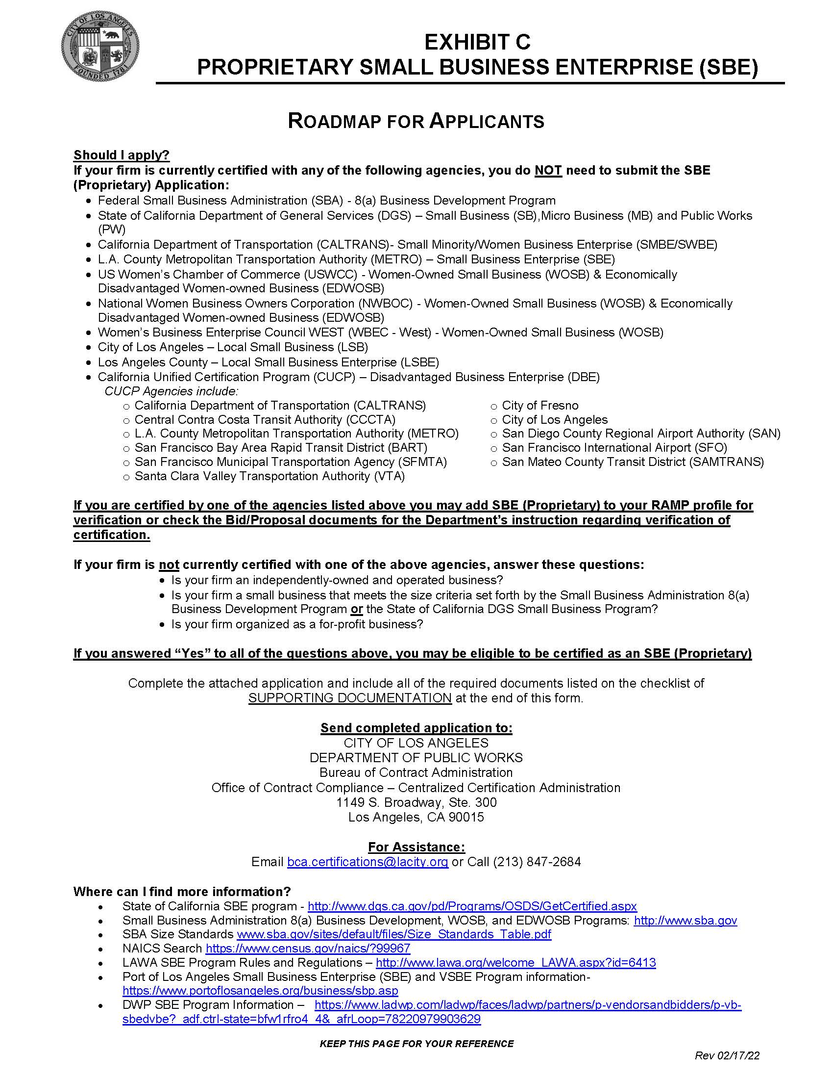
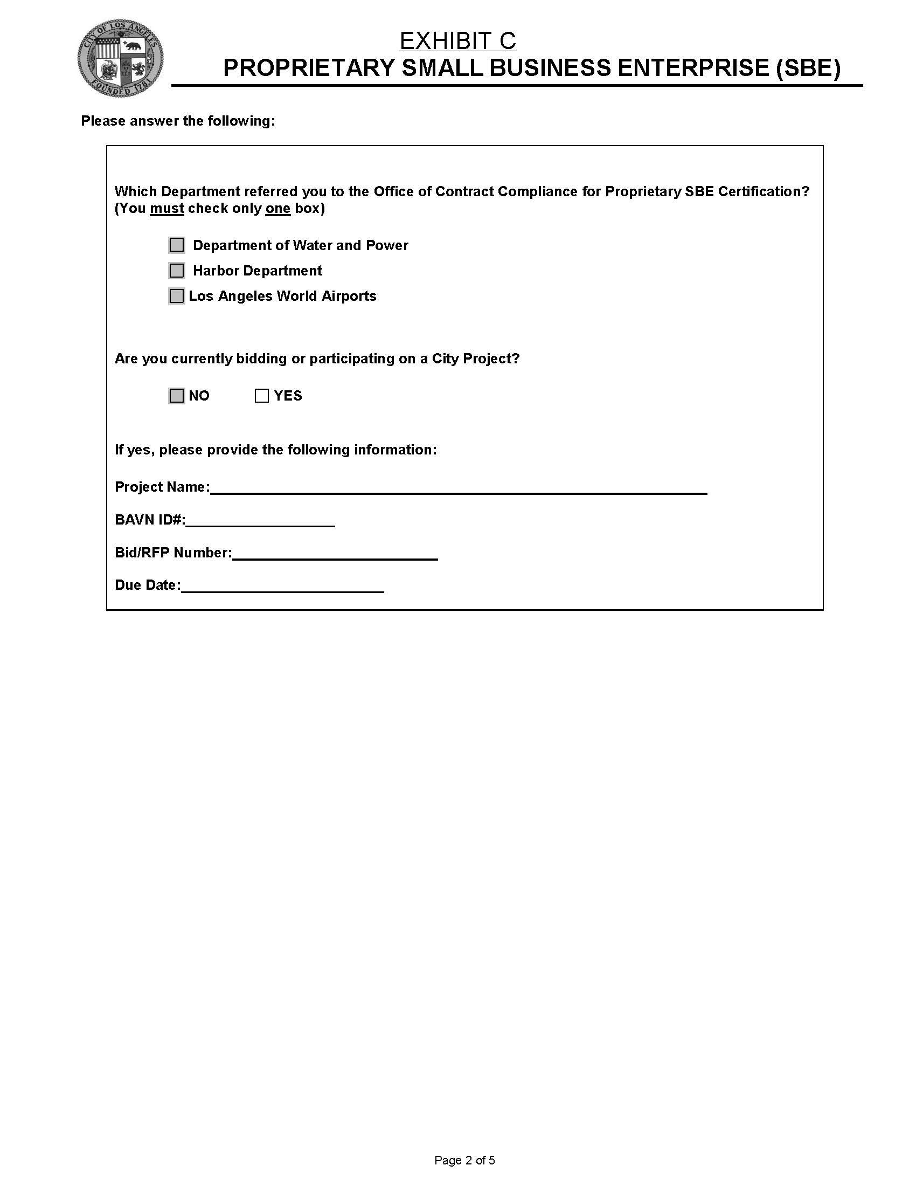
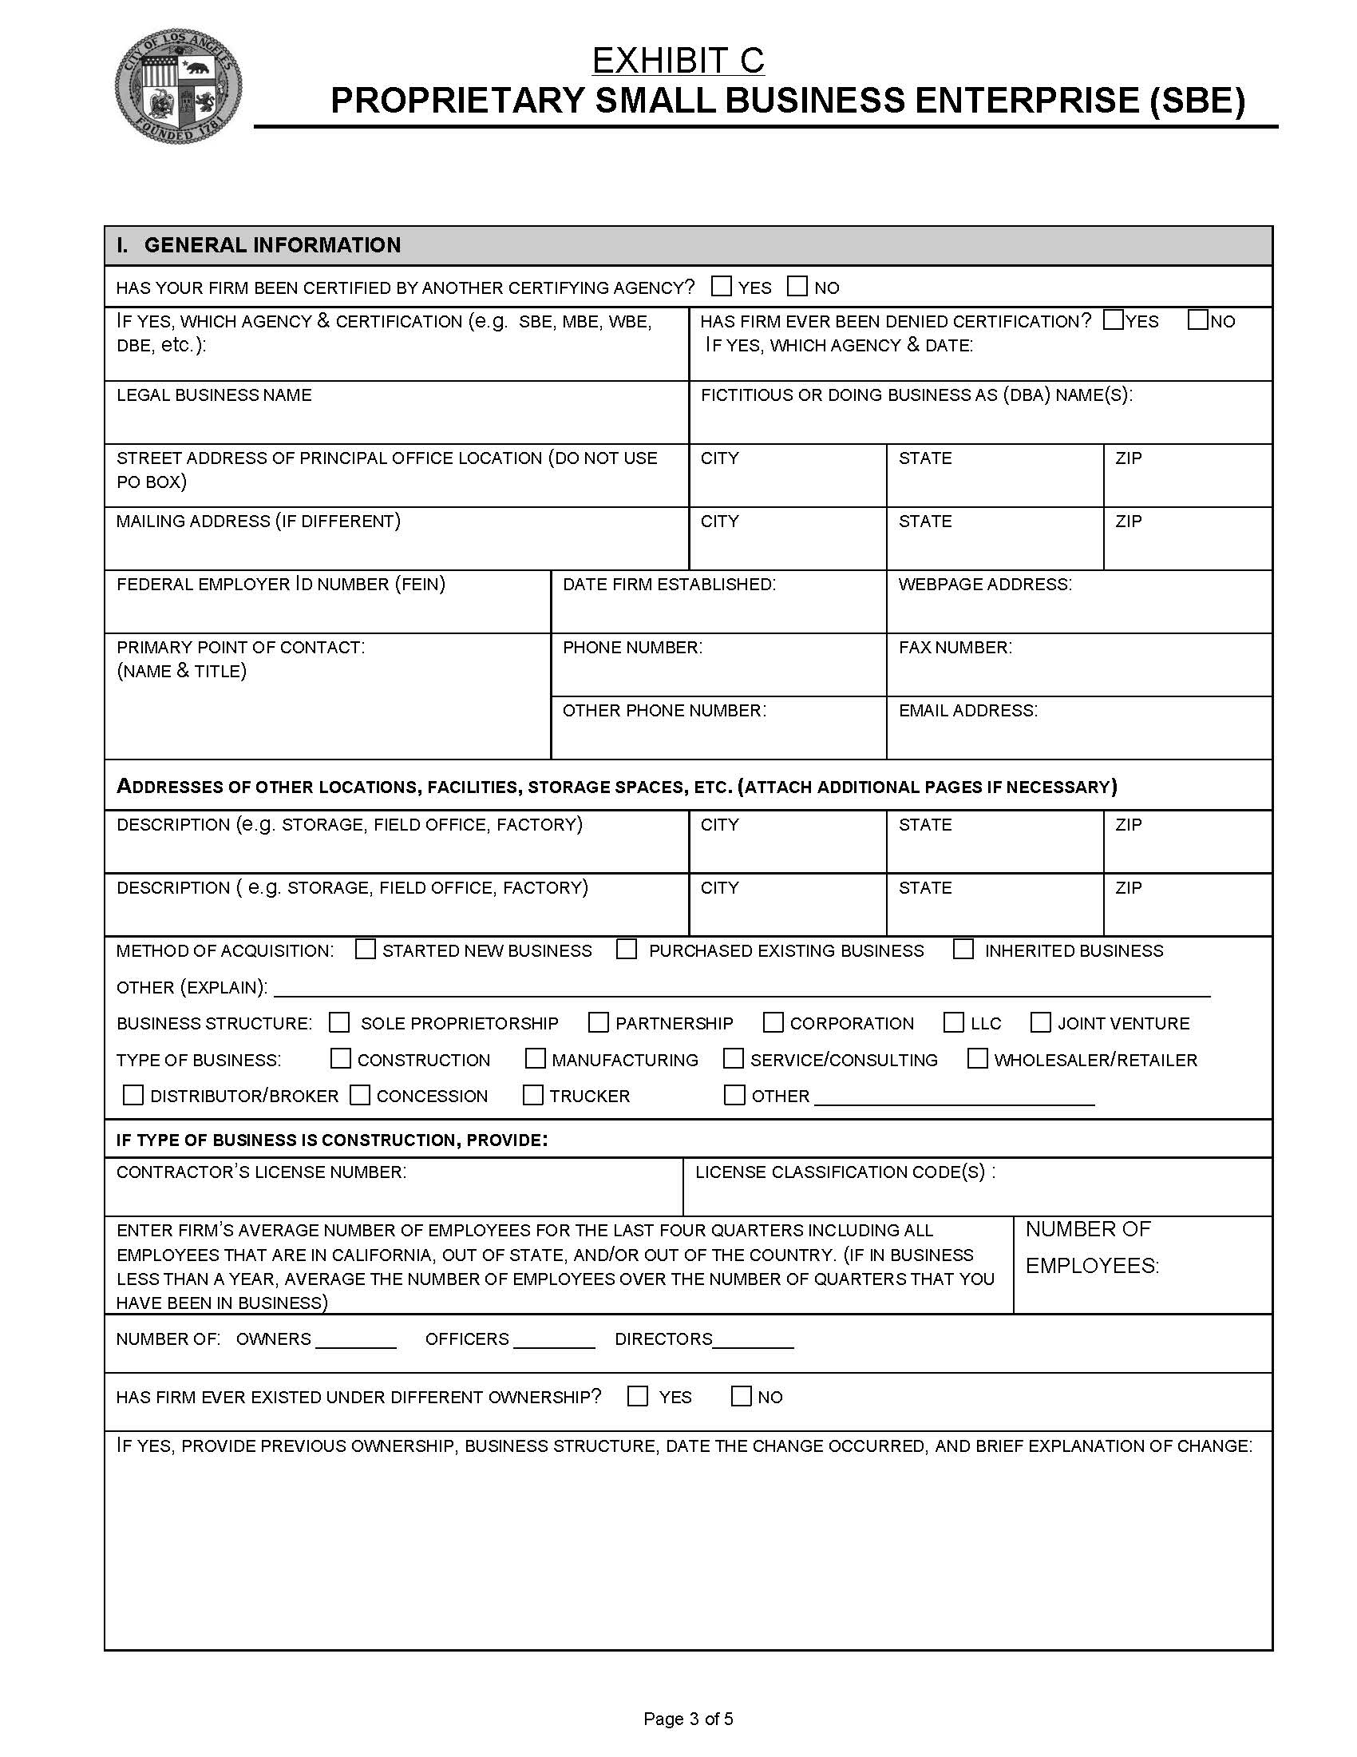
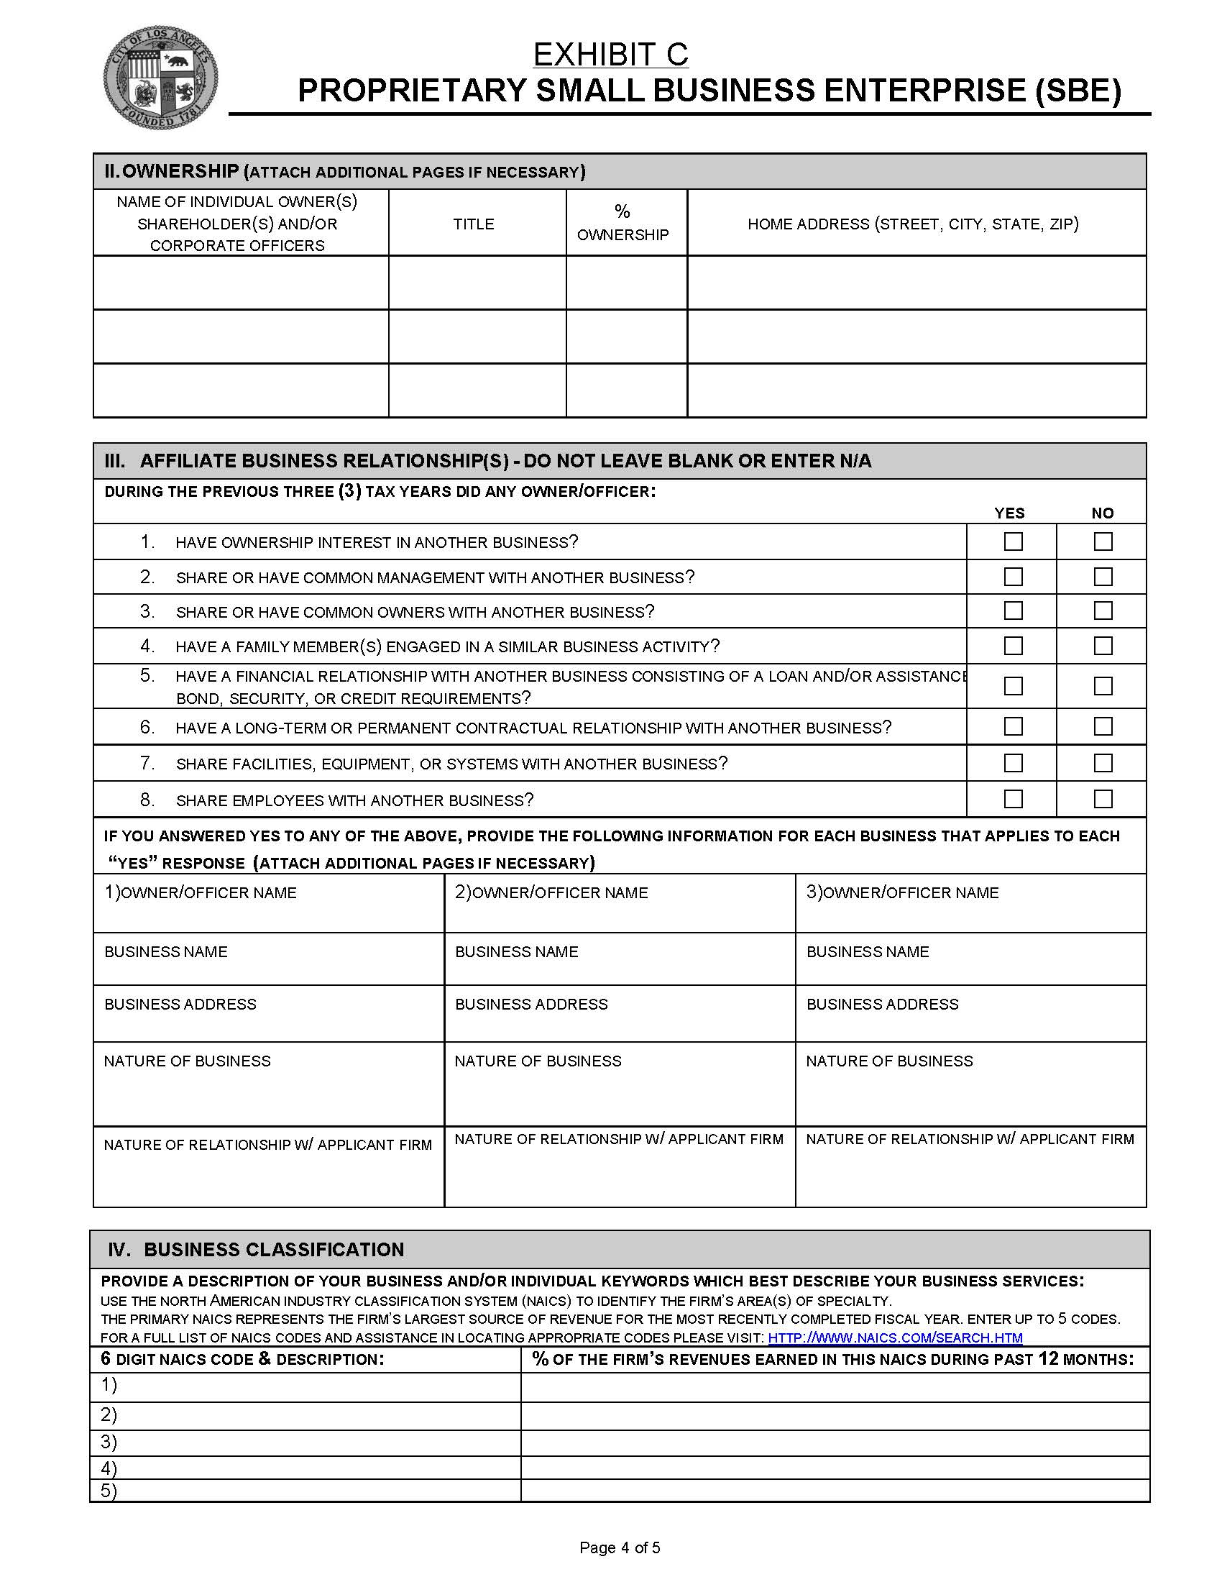
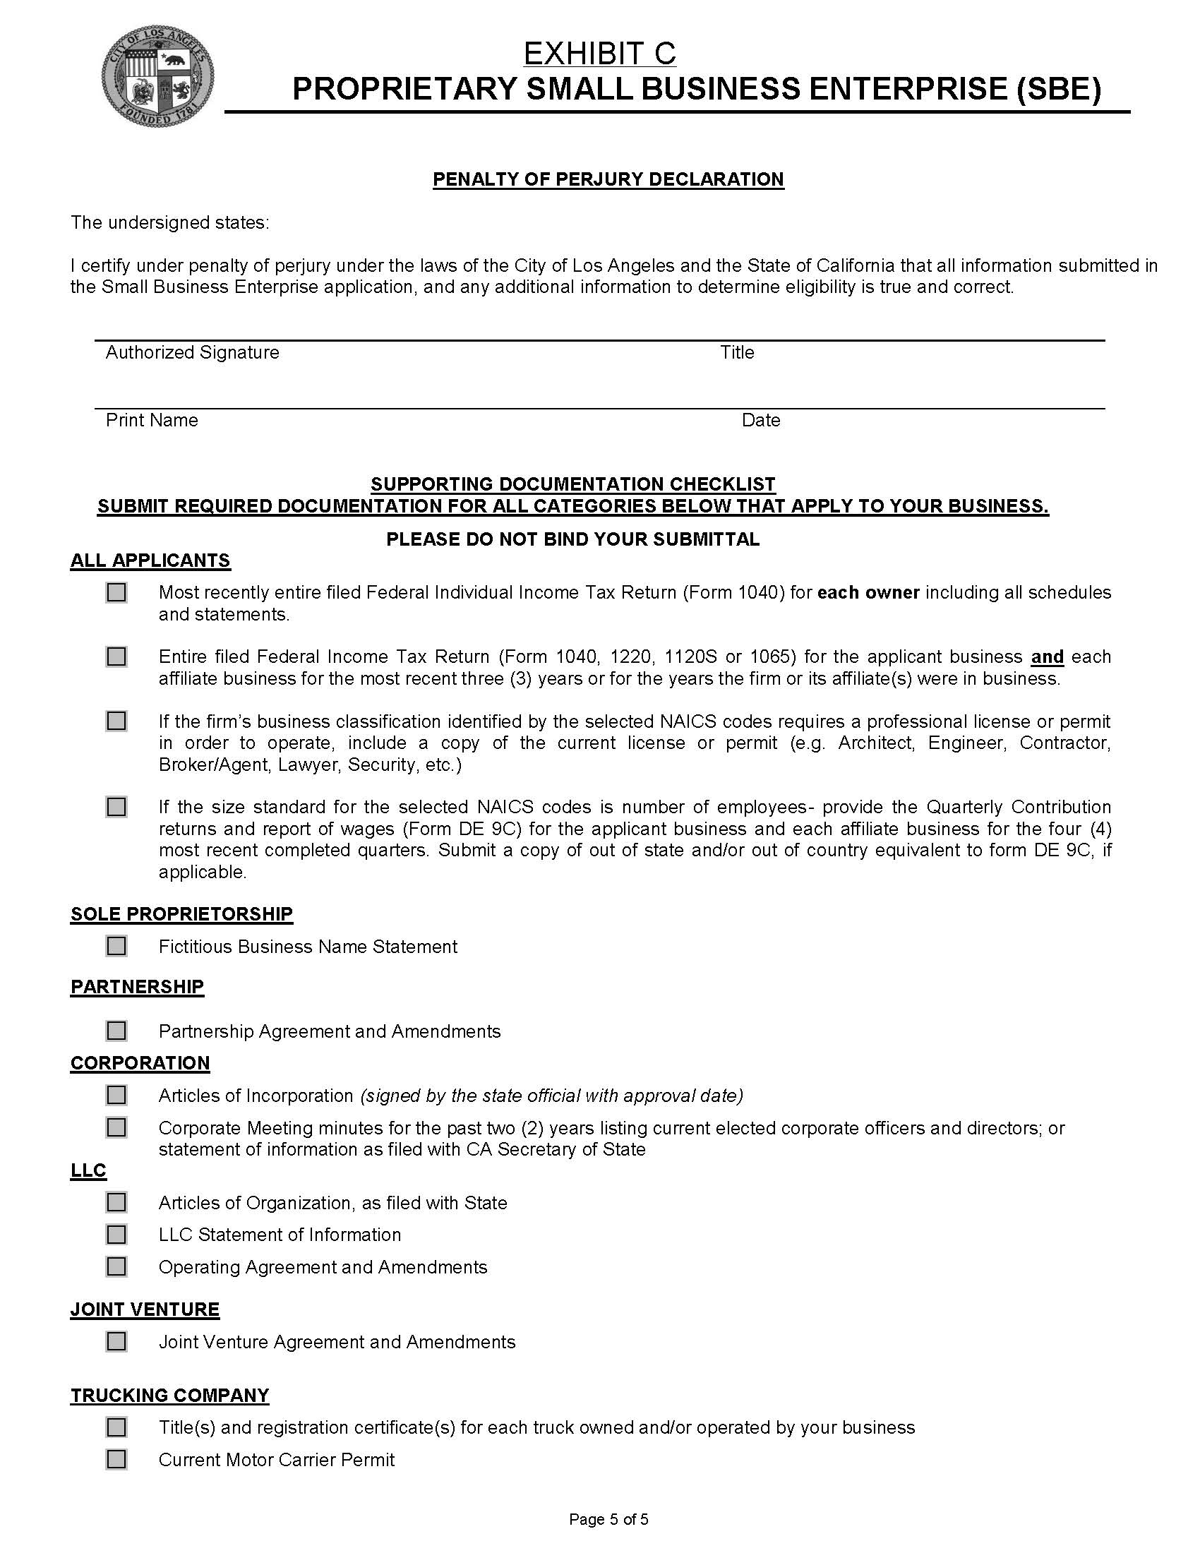
Exhibit D - Business Tax Registration Certificate (BTRC) Number

The City of Los Angeles, Office of Finance requires all firms that engage in any business activity within the City of Los Angeles to pay City business taxes. Each firm or individual (other than a municipal employee) is required to obtain the necessary Business Tax Registration Certification (BTRC) and pay business tax. (Los Angeles Municipal code Section 21.09 et seq.)

All firms and individuals that do business with the City of Los Angeles will be required to provide a BTRC number or an exemption number as proof of compliance with Los Angeles City business tax requirements in order to receive payment for goods or services. Beginning October 14, 1987, payments for goods or services will be withheld unless proof of tax compliance is provided to the City.

The Tax and Permit Division of Los Angeles Office of Finance, has the sole authority to determine whether a firm is covered by business tax requirements. Those firms not required to pay will be given an exemption number.

If you do NOT have a BTRC number contact the Tax and Permit Division at the office listed below, or log on to http://finance.lacity.org/, to download the business tax registration application.

MAIN OFFICE
LA City Hall 201 N. Main Street, Rm. 101 (844) 663-4411

Exhibit E- Equal Benefits Ordinance

Sec. 10.8.2.1. Equal Benefits Ordinance.

Discrimination in the provision of employee benefits between employees with domestic partners and employees with spouses results in unequal pay for equal work. Los Angeles law prohibits entities doing business with the City from discriminating in employment practices based on marital status and/or sexual orientation. The City's departments and contracting agents are required to place in all City contracts a provision that the company choosing to do business with the City agrees to comply with the City's nondiscrimination laws.

It is the City's intent, through the contracting practices outlined in this Ordinance; to assure that those companies wanting to do business with the City will equalize the total compensation between similarly situated employees with spouses and with domestic partners. The provisions of this Ordinance are designed to ensure that the City's contractors will maintain a competitive advantage in recruiting and retaining capable employees, thereby improving the quality of the goods and services the City and its people receive, and ensuring protection of the City's property.

(c) Equal Benefits Requirements.

(1) No Awarding Authority of the City shall execute or amend any Contract with any Contractor that discriminates in the provision of Benefits between employees with spouses and employees with Domestic Partners, between spouses of employees and Domestic Partners of employees, and between dependents and family members of spouses and dependents and family members of Domestic Partners.

(2) A Contractor must permit access to, and upon request, must provide certified copies of all of its records pertaining to its Benefits policies and its employment policies and practices to the DAA, for the purpose of investigation or to ascertain compliance with the Equal Benefits Ordinance.

(3) A Contractor must post a copy of the following statement in conspicuous places at its place of business available to employees and applicants for employment: "During the performance of a Contract with the City of Los Angeles, the Contractor will provide equal benefits to its employees with spouses and its employees with domestic partners." The posted statement must also include a City contact telephone number which will be provided each Contractor when the Contract is executed.

(4) A Contractor must not set up or use its contracting entity for the purpose of evading the requirements imposed by the Equal Benefits Ordinance.

(d) Other Options for Compliance. Provided that the Contractor does not discriminate in the provision of Benefits, a Contractor may also comply with the Equal Benefits Ordinance in the following ways:

(1) A Contractor may provide an employee with the Cash Equivalent only if the DAA determines that either:

a. The Contractor has made a reasonable, yet unsuccessful effort to provide Equal Benefits; or

b. Under the circumstances, it would be unreasonable to require the Contractor to provide Benefits to the Domestic Partner (or spouse, if applicable).

(2) Allow each employee to designate a legally domiciled member of the employee's household as being eligible for spousal equivalent Benefits.

(3) Provide Benefits neither to employees' spouses nor to employees' Domestic Partners.

(e) Applicability.

(1)Unless otherwise exempt, a Contractor is subject to and shall comply with all applicable provisions of the Equal Benefits Ordinance.

(2) The requirements of the Equal Benefits Ordinance shall apply to a Contractor's operations as follows:

a. A Contractor's operations located within the City limits, regardless of whether there are employees at those locations performing work on the Contract.

b. A Contractor's operations on real property located outside of the City limits if the property is owned by the City or the City has a right to occupy the property, and if the Contractor's presence at or on that property is connected to a Contract with the City.

c. The Contractor's employees located elsewhere in the United States but outside of the City limits if those employees are performing work on the City Contract.

(3) The requirements of the Equal Benefits Ordinance do not apply to collective bargaining agreements ("CBA") in effect prior to January 1, 2000. The Contractor must agree to propose to its union that the requirements of the Equal Benefits Ordinance be incorporated into its CBA upon amendment, extension, or other modification of a CBA occurring after January 1, 2000.

(f) Mandatory Contract Provisions Pertaining to Equal Benefits. Unless otherwise exempted, every Contract shall contain language that obligates the Contractor to comply with the applicable provisions of the Equal Benefits Ordinance. The language shall include provisions for the following:

(1) During the performance of the Contract, the Contractor certifies and represents that the Contractor will comply with the Equal Benefits Ordinance.

(2) The failure of the Contractor to comply with the Equal Benefits Ordinance will be deemed to be a material breach of the Contract by the Awarding Authority.

(3) If the Contractor fails to comply with the Equal Benefits Ordinance the Awarding Authority may cancel, terminate or suspend the Contract, in whole or in part, and all monies due or to become due under the Contract may be retained by the City. The City may also pursue any and all other remedies at law or in equity for any breach.

(4) Failure to comply with the Equal Benefits Ordinance may be used as evidence against the Contractor in actions taken pursuant to the provisions of Los Angeles Administrative Code Section 10.40, et seq., Contractor Responsibility Ordinance.

(5) If the DAA determines that a Contractor has set up or used its Contracting entity for the purpose of evading the intent of the Equal Benefits Ordinance, the Awarding Authority may terminate the Contract on behalf of the City. Violation of this provision may be used as evidence against the Contractor in actions taken pursuant to the provisions of Los Angeles Administrative Code Section 10.40, et seq., Contractor Responsibility Ordinance.

EXHIBIT F
RFP SELECTION EVALUATION FORM

PROJECT: Customs and Border Protection Security Systems Maintenance and Repair

SCORING GUIDELINES:
Rater’s Score: (Range 0-5) - 0=not included/non responsive; 1= Serious Deficiencies; 2=Marginal Abilities; 3=Adequate, 4=Well Qualified; 5=Exceptionally Qualified.
Scores must be whole numbers only (for example, “3.5” is not acceptable).
Weighing Factor: A range of 1 through 6, with 1 being of relative lower importance and 6 being relative highest importance. Each number (1 through 6) may be used more than once; however, in establishing weights, the total of all the weighing factors (A –E) must equal 20. Example: 3+2+6+4+5=20 or 3+3+3+6+5=20
Weighted Score= Rater’s Score multiplied by (x) Weighing Factor. Totals should be calculated for each criterion.
Total score = Sum of all weighted scores.

Firm Name | Evaluated by | Date

Criteria To be Rated |  | Rater’s Score | Weighing Factor | Weighted Score
- Firm Qualifications, Experience and References | How long has the company been in business? Has the company done similar work? Level of expertise in subject matter areas? |  | 5
- Project Organization, Personnel and Staffing | Qualification and experience of proposed personnel for requested services? On-site availability of team and project manager? Locally based firm or team? |  | 6
- Project Approach, Work Plan, Management | Quality of proposed approach and work plan to meet project requirements? Quality of project management? |  | 4
- Rates, Fees and Budget Control | Competitive rates and fees proposed? Are proposed budget management, fees and staff hours proposed and clearly defined? |  | 4
- Clarity and Comprehensiveness of the Proposal | Is the proposal clear, comprehensive, and understandable? |  | 1
 | Maximum points possible=100 |  | A+B+C+D+E=20 | Total Points=

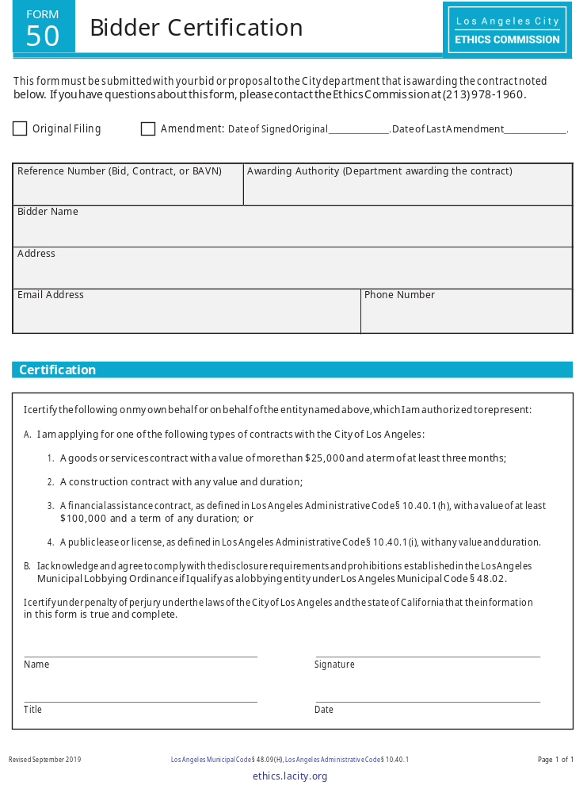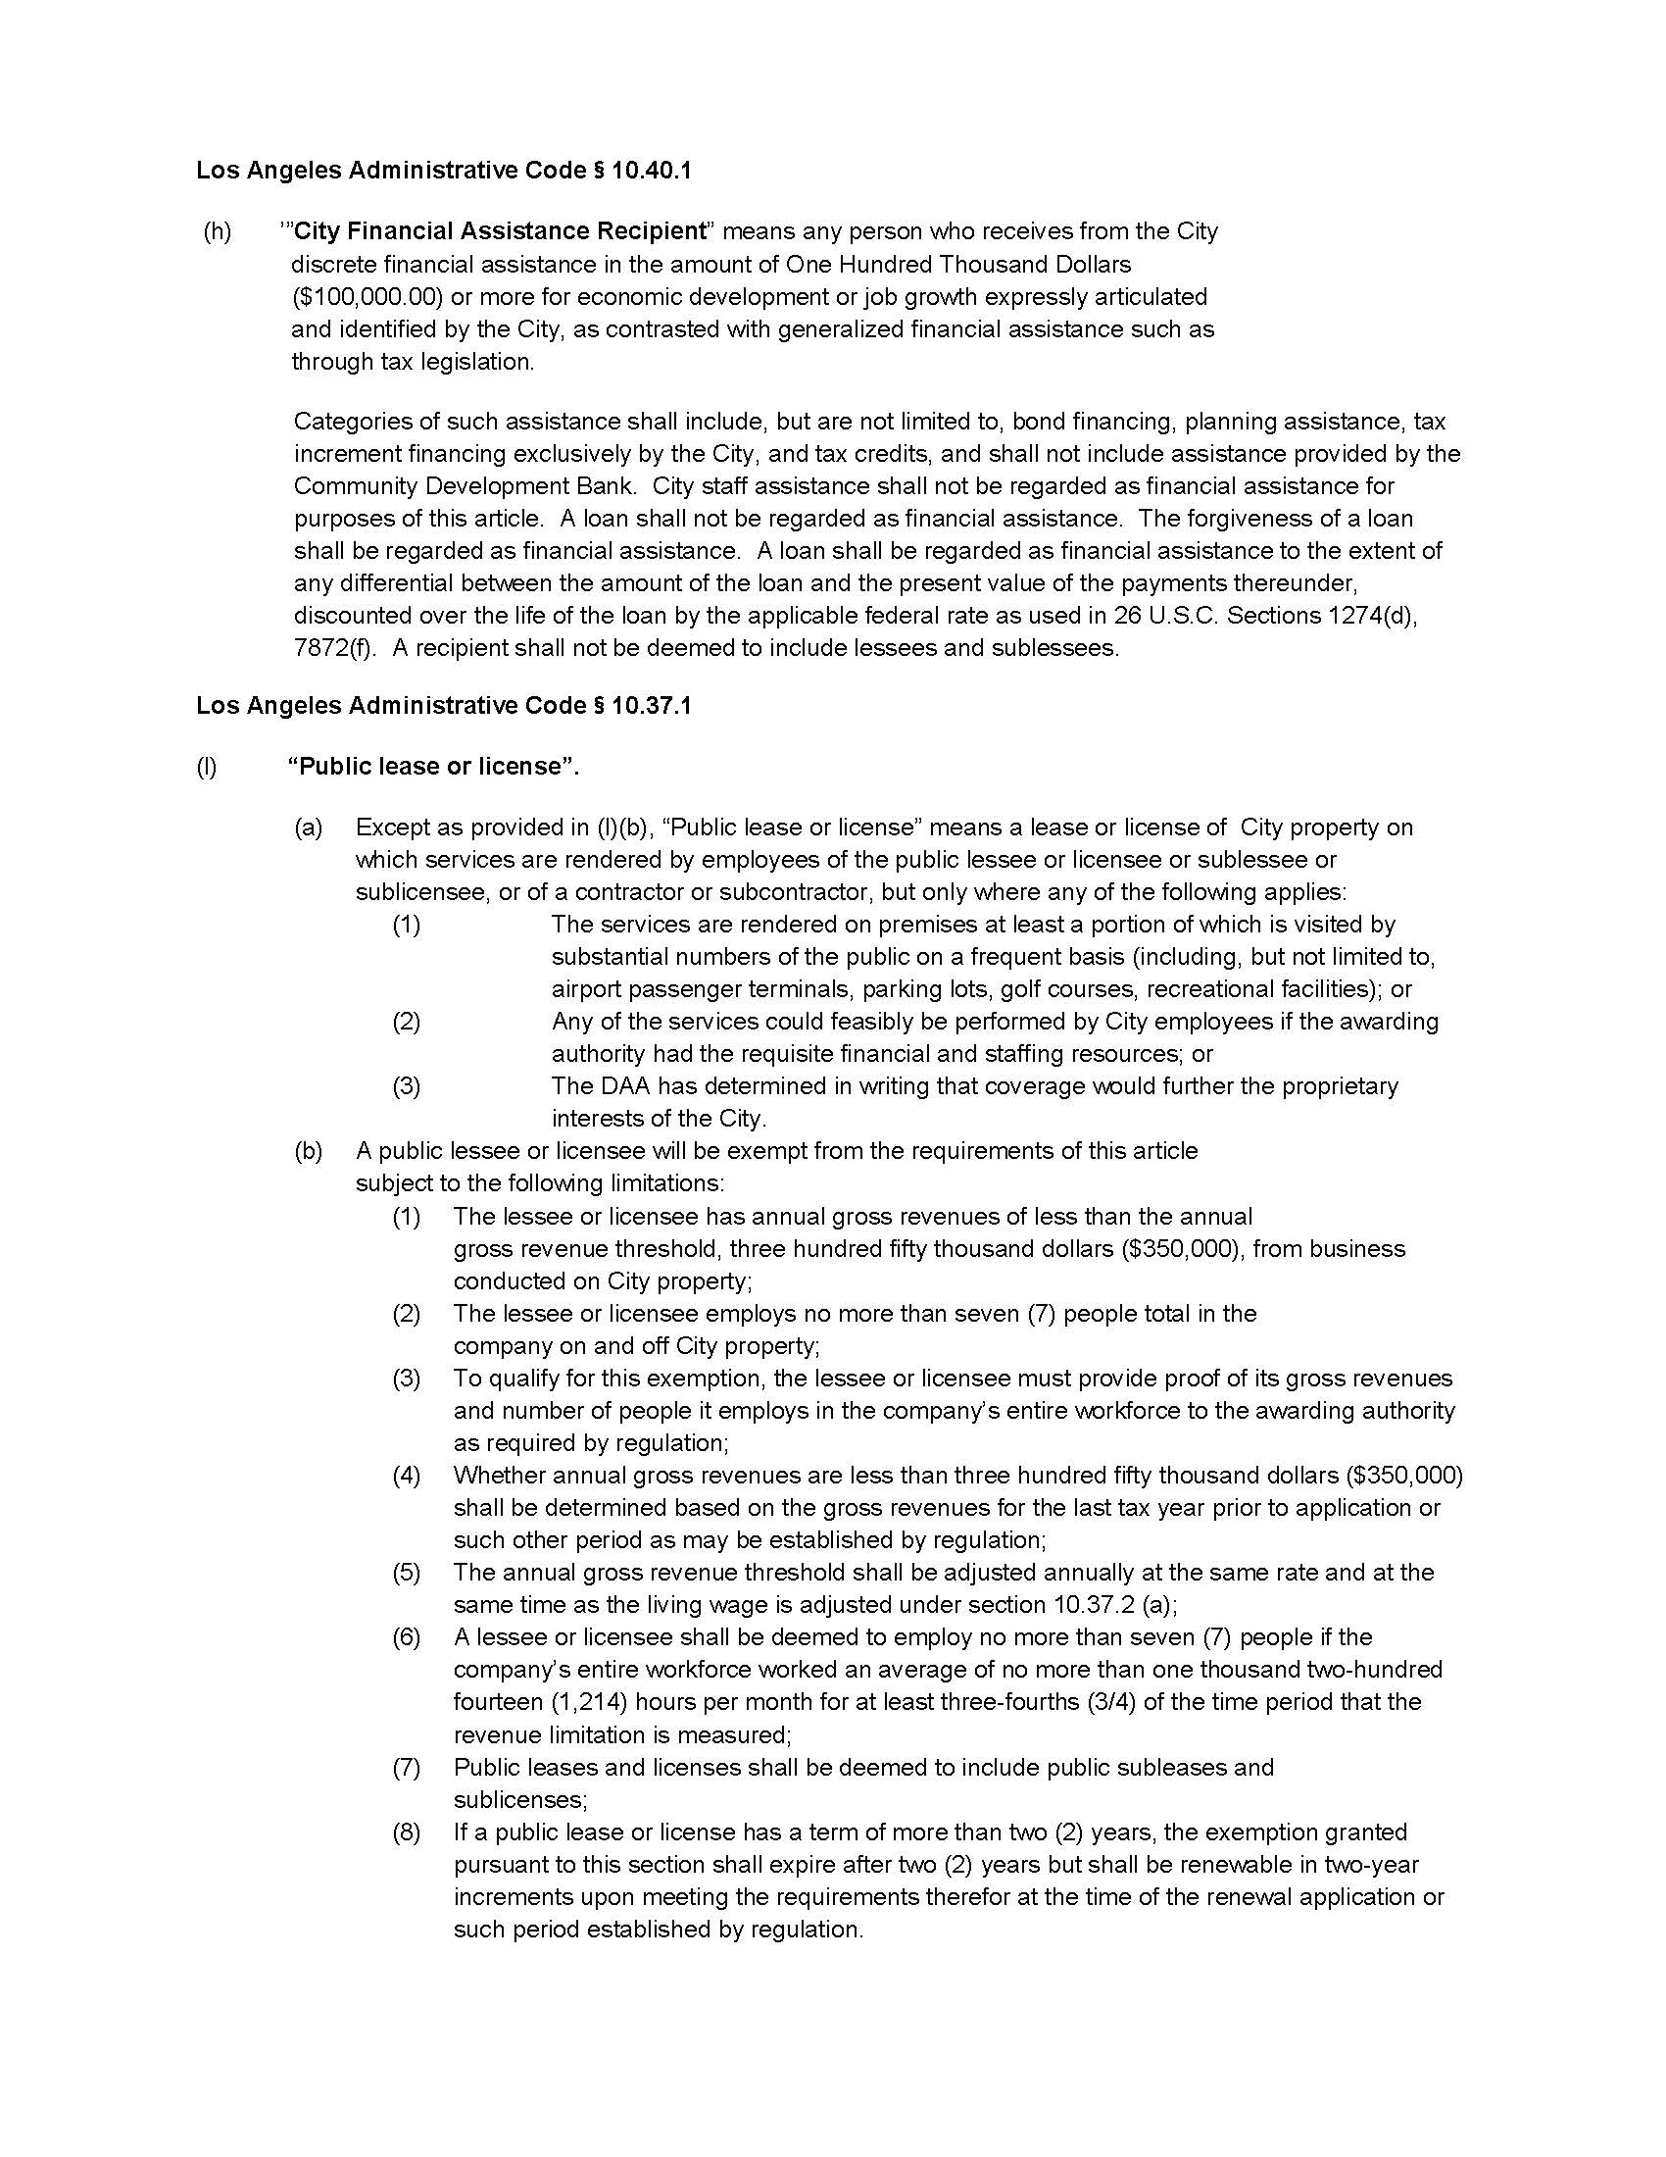
EXHIBIT G


